CITY OF GRAPEVINE & GRAPEVINE FIRE
DEPARTMENT
DEMAND ANALYSIS FOR EMS MEDIC UNITS

DEMAND ANALYSIS FOR EMS MEDIC UNITS OF THE
CITY OF GRAPEVINE
AND THE GRAPEVINE FIRE DEPARTMENT

Table of Contents
Acknowledgments iii
Preface / Acknowledgements 1
Report Section 1
Evaluation of Current Conditions 3
Current and Future Service Demand 4
Service Delivery and Response Performance 6
Analysis of Historic Turnout Times for EMS Responses 11
EMS Demand Distribution 13
EMS Demand Distribution by Unit 17
EMS Ambulance Transports 22
Report Section 2
Computer Aided Dispatch (CAD) Data Analysis for System Status Management 27
Technology Solution to Achieve EMS System Effectiveness 33
EMS Staffing for a High-Performance Fire EMS System 35
Suggested Operational Adjustments 39
What’s Necessary to Ensure Successful Improvement? 41
Current Challenges in EMS System Improvement 42
Report Section 3
Creating a High-Performance Fire EMS Response organization 44
The Concept of Community Risk Reduction 45
How Many Resources Do We Really Need? 47
How to Calculate Unit Hour Utilization 50
Unit Hour Analysis Summary 52
Report Section 4
Establishing Key Performance Indicators to Assist with EMS Critical Decision-Making 53
Key Performance Indicators: What to Measure & Why 54
What’s Necessary to Ensure Improvement? 56
Current Challenges in EMS 57
Where to Start? 59
How Should I Use KPIs to Measure and Optimize? 60
Key Performance Indicators: Where Do We Start? 61
Data Challenges 64
Changes & Results 65
A Continued Commitment 66
Summary of Recommendations Appendix Reference Information
A - Calculating Your EMS Service's "Average Cost of Service" and "Unit Hour Analysis"

Acknowledgments
Without the considerable support of the leadership of the City of Grapevine, this project would not have been possible. Strategic Government Resources thanks and acknowledges the following representatives for their invaluable contribution to this undertaking.

Grapevine Fire Department
Darrell Brown, Fire Chief
Stuart Grant, Deputy Fire Chief, Operations
John Sherwood, Deputy Chief, Fire Administration Brent Irving, EMS Division Chief
Justin R. Northeim, D.O. Grapevine Fire Department Medical Director

iii

Preface / Acknowledgements

Strategic Government Resources (SGR) was engaged by the City of Grapevine to provide an Emergency Medical Services capacity and staffing demand and delivery analysis within the Grapevine Fire Department (THE GRAPEVINE FIRE DEPARTMENT) service area. This EMS Demand and Delivery analysis will assist the department in future planning and provision of comprehensive emergency services to the citizens of Grapevine. This report is organized as a service delivery analysis and overview that evaluates current conditions; projects future growth, development, and service demand; and provides recommendations to enhance current services, or to provide an equal level of service, over the next five to 10 years.

SGR thanks the City of Grapevine, and the staff of the Grapevine Fire Department, for their cooperation in the preparation of this report. All involved were candid in their comments and provided a tremendous amount of essential information.
Special appreciation is offered to Fire Chief Darrell Brown, Assistant Chiefs John Sherwood and Stuart Grant, and Division Chief Brent Irving in acknowledgement of the time, effort, and resources they provided for data collection included in this report. A special thanks is also extended to Dr. Jason Northeim, EMS Medical Director for the Grapevine Fire Department, for his insight and comments on how the Grapevine Fire Department can evolve to become a premier example of High Performance EMS service delivery in Tarrant County.
The EMS Demand and Delivery Analysis began with a review of the current service delivery provided by The Grapevine Fire Department including its programs, administration, management, service delivery performance, and efficiency. All areas related to the delivery of EMS in the City of Grapevine are evaluated and discussed in detail and specific recommendations are provided, where applicable.

Fire service based EMS is not only response, treatment and transport-the back office and support functions are the “power behind the punch” of service delivery. The creation of lean, efficient and measurable systems is the key to success, today and into the future. An example of this is a high functioning fleet

service. If your vehicles fail on the way to calls, then so does the mission. Keeping your organization well serviced and maintained is an arterial function and performance could hemorrhage if you can’t get to where you need to go. The swift conversion of treatment, to bill, to income is also an essential function.
Remembering the economic requirement that we turn the amount of available funds into quality healthcare requires the generation of said funds to keep the EMS circle of life turning. While those in support functions are not delivering lifesaving and patient care, they keep the organization alive and healthy.

Section I

Evaluation of Current Conditions

An analysis of current conditions is documented in four survey sections, reviewing the EMS operations of the Grapevine Fire Department: Current EMS Operations, Dispatch and emergency response data availability, suggested elements of a high- performance EMS organization, and establishing key performance initiatives for the future. Each component of the evaluation includes an introductory explanation of the subject area and discussion of desirable outcomes and identified best practices.
Various criterion used to evaluate a fire department has been developed over many years. These gauges include relevant guidelines from national accreditation criteria, the National Fire Protection Association (NFPA) standards, federal and state mandates for fire and EMS systems, recommendations by various organizations such as the Commission for Accreditation of Ambulance Services (CAAS), and generally accepted best practices within the fire and EMS industry.
The evaluation of current conditions offers the City a detailed assessment of existing Emergency medical service operations by the fire department and also provides the SGR project team with a snapshot in time; the basis from which the balance of the Fire Department EMS program and service audit is developed. The following discusses some of the key findings:

Current and Future Service Demand

The Grapevine Fire Department is a municipal subdivision of the City of Grapevine, Texas. Grapevine is located in the North Central Texas Metroplex region, immediately adjacent, and to the Northwest of the Dallas - Ft. Worth International Airport. The fire department’s EMS service area encompasses approximately 27.2 square miles that fall within the city. The service area population consists of 48,447 residents with a combined resident, conference, and resort population of up to 110,000 at various times of the day, year around.
The City of Grapevine and adjacent areas are experiencing consistent and significant daytime recreational/conference and business population growth, which has a strong potential to continue into the future. With community population and business growth comes increasing service demand and workload on the fire department, challenging the agency to keep pace with growing needs. Over the years, the department has evolved into the agency it is today providing fire prevention and suppression, technical rescue, hazardous materials and advanced life support (ALS), medical first response, and transportation services. The department operates from five strategically placed facilities using a fleet of three "quint" engines, and one ladder truck) with ALS ? capabilities, a heavy rescue response unit, three Mobile Intensive Care Unit (MICU) ambulances, and a number of ancillary and support vehicles. The department is staffed by entirely career personnel that include an administrative complement of 11 and an operations complement of 90 personnel.

The North Central Texas Council of Governments (NCTCOG) prepares population projections for communities throughout the 16 counties in the region. For the period from April 1 2010 to April 1 of 2019, the North Central Texas Council of Governments reported the following estimate of population in the City of Grapevine.

YEAR | POPULATION AS OF JANUARY 1 | CHANGE FROM PREVIOUS  YEAR
2010 | 46334 (April 1)
2011 | 46300 | -.001%
2012 | 46420 | +0026%
2013 | 47070 | +1.4%
2014 | 48060 | +2.1%
2015 | 48520 | +0.9%
2016 | 48920 | +0.8%
2017 | 49130 | +0.4%
2018 | 49240 | +0.2%
2019 | 51370 | +4.3%
Source: 2019 NCTCOG Population Estimates Publication

This population projection shows the household population of Grapevine increasing approximately 4.3 percent from 2020 through 2030, to a population of approximately 55,000. Furthermore employment in Grapevine is forecast to increase by only a little more than % in the same 10 year period. This is inevitably the result of the city reaching build-out, the point at which there is little remaining land available for residential development within the current boundaries of Grapevine.

GRAPEVINE HOUSEHOLD ESTIMATE
2020 | 2030 | GROWTH | CHANGE
45,440 | 49,484 | 4,044 | +8.9%
GRAPEVINE EMPLOYMENT ESTIMATE
84,615 | 85,475 | 860 | +1.02%
Source:2019 NCTCOG Demographics Estimate

Service Delivery and Response Performance

Emergency medical Service response performance criteria and actual service delivery performance is analyzed in detail, providing information with which the Department can develop future EMS deployment methodologies and identify desired levels of response performance and staffing.

Emergency medical responses were examined for a 24 month period from April 2017 through March of 2019. The number of EMS responses for each of those months is shown in Figure 1 and 2.

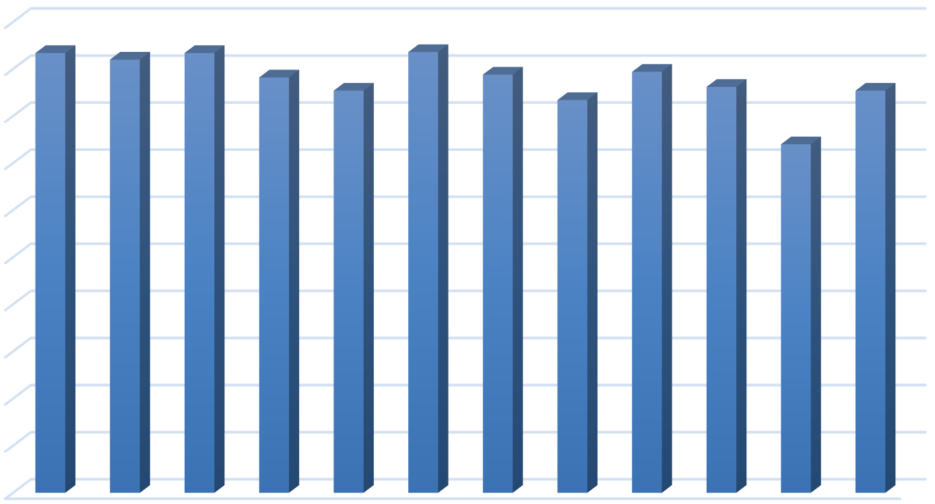
GFD Apr 2017 to Mar 2018 EMS Runs
500 467
460
467
468
441
444
447
450
400
350
427
417
431
427
370
300
250
200
150
100
50
0
2017 2017 2017 2017 2017 2017 2017 2017 2017 2018 2018 2018
Apr May Jun Jul Aug Sep Oct Nov Dec Jan Feb Mar
Figure 1

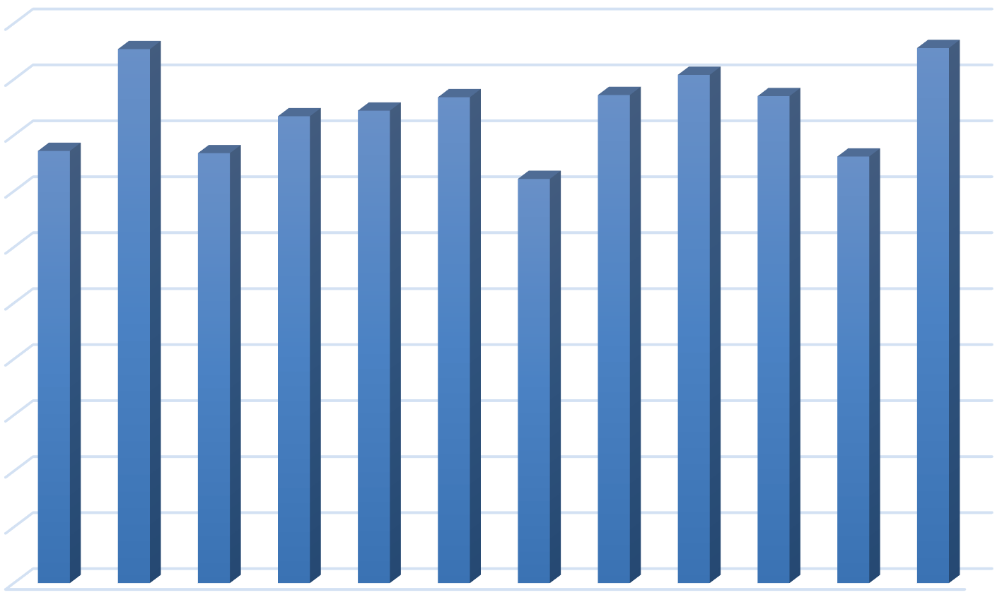
GFD Apr 2018 to Mar 2019 EMS Runs
500
477
478
454
450
417
422
434
436
435
400
386
384
381
361
350
300
250
200
150
100
50
0
2018 2018 2018 2018 2018 2018 2018 2018 2018 2019 2019 2019
Apr May Jun Jul Aug Sep Oct Nov Dec Jan Feb Mar

Figure 2

Demands for EMS for the 12 month period of April 1 2017 to March 31 2018 the department responded to a total of 5,266 call for service. For the 12 month period of April 1 2018 to March 31 2019 the department responded to a total of 5,065 calls for service. The demands for EMS service calls has risen for the department by as much as 44% since 2013, when the department responded to a total of 3,514 calls for EMS service. The number of calls for 2017 and 2018 may indicate that this growth trend has stabilized. The department should consider to monitor the number of EMS call for service on a yearly basis to determine demand growth trends.

Recommendation #1 - Monitor the total calls for EMS on a annual basis to stay abreast of demand trends from year to year and over at least a 5-10 year period.
Historical EMS response times in the period of April 1, 2018 to March 31, 2019 were found to average 6 minutes 33 seconds. Ambulance response time varied based on the travel distance and traffic conditions present at the time of the

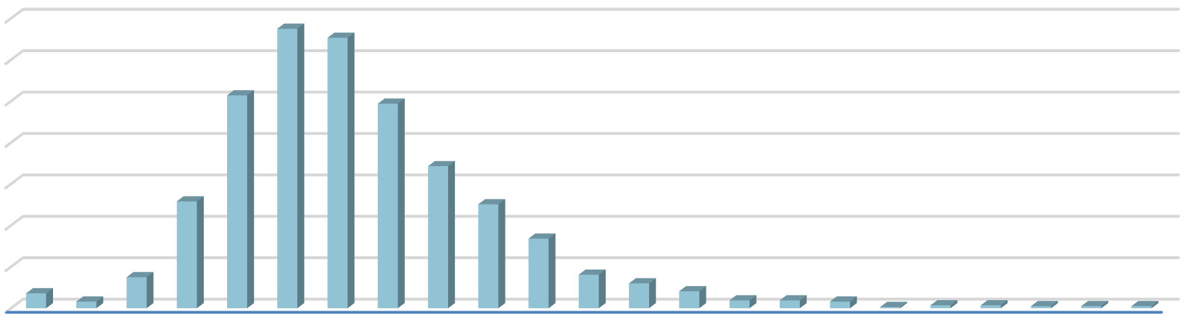response. The distribution of EMS calls based on the response time is shown in Figure #3.
MICU Response Times
Apr 18 to Mar 19
700
600
500
400
300
675 653
514
494
343
258
251
200
100
0
168
36
75
81
16
60
41
19 19 16
3 7 7
5 5 5
Response Time in Minutes
Number of Runs

Figure 3
0:00
1:00
2:00
3:00
4:00
5:00
6:00
7:00
8:00
9:00
10:00
11:00
12:00
13:00
14:00
15:00
16:00
17:00
18:00
19:00
20:00
21:00
22:00

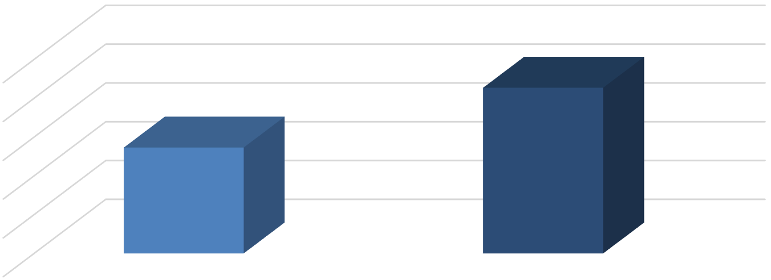Looking at EMS incidents to which the Department responded in the same time period of April 1, 2018 to March 31, 2019, 90 percent were answered in 10 minutes 15 seconds or less, as shown in Figure 4. I want to confirm that the times shown in Figure #4 are from receipt of call in the 9-1-1 center (PSAP), to arrival of an ambulance, from dispatch to arrival of ambulance, or arrival of first unit (either engine or ambulance?)
Average and 90th Percentile MICU Response Times
(Apr 18 to Mar 19)
10:15
12:00
9:36
7:12
4:48
2:24
0:00
6:33
Average Response Time
90th Percentile Response Time

Figure 4
Response Time

Recommendation #2 - The fire department should set an EMS standard for Total Response Time, and report department performance at the 90th percentile, by individual first arriving vehicle, on a monthly basis.
Recommendation #3 - The fire department should set a standard for Response Time , and track and report department performance at the 90th percentile, by the first arriving responder, from receipt of call to EMS Responder at patient's side.
The average and 90th percentile response times shown in Figure 4 are composed of 4 different element elapsed times. Those individual elements are: Call Processing time, Turnout time, Travel Time, and the cumulative Total Response time. The call processing time is the time is takes from initial receipt of the EMS request for service through the process of determining the caller's exact location, situation or nature of the emergency, closest available response vehicle location, and notification of the closest available response vehicle. Travel Time consists of the time that the assigned response vehicle begins moving toward the location of the EMS emergency, and its arrival at the designated location. The individual element times for the average and 90th percentile response times are shown in Figure 5.

 |  | Total Response Time Continuum
 | Call Processing |  | Turnout Time | Travel Time |  | Total Response  Time
Average | 0.02 |  | 1:08 | 5:25 |  | 6:33
90th Percentile | 0 |  | 2:03 | 8:12 |  | 10:15
Figure 5

Recommendation #4 - The fire department, in conjunction with the 9-1-1 dispatch entity, should establish a standard for Call Processing time and set the 90th Percentile for call handling at 60 seconds.
Recommendation #5 - The 90th Percentile Call Processing times should be monitored and published on a monthly basis for compliance with the established standard.

Analysis of Historic Turnout Times for EMS Responses

Turnout time, or that time from notification of the assigned response vehicle(s) for an EMS incident to the point the vehicle is actually enroute to the incident, is an element of Total Response time that is under complete control my emergency responders. The typical fire department is at a disadvantage with is element of the response timeline because fire department units will usually be at a fixed location, i.e. fire station, as opposed to already being mobile, on the street.
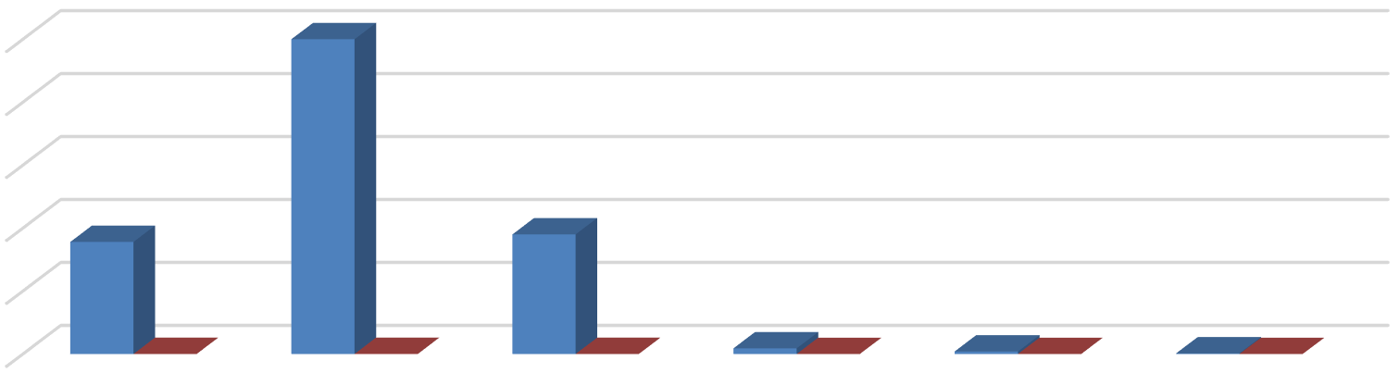Turnout times for EMS responses for the period of April 1, 2018 to March 31, 2019 were examined for the Grapevine Fire Department. Turnout times for EMS responses between the hours of Midnight and 8:00 AM, and the time distribution are shown in Figure 6.
Turnout Times by Hour of Day
12mn to 0800
500
500
400
300
200
178
190
100
0
3.51%
9.87%
3.75% 9 0.18% 4 0.08%
1 0.02%
0 to 1 min 1 to 2 min 2 to 3 min 3 to 4 min 4 to 5 min >5 min
Turnout Time in Minutes
Number of Runs

Figure 6

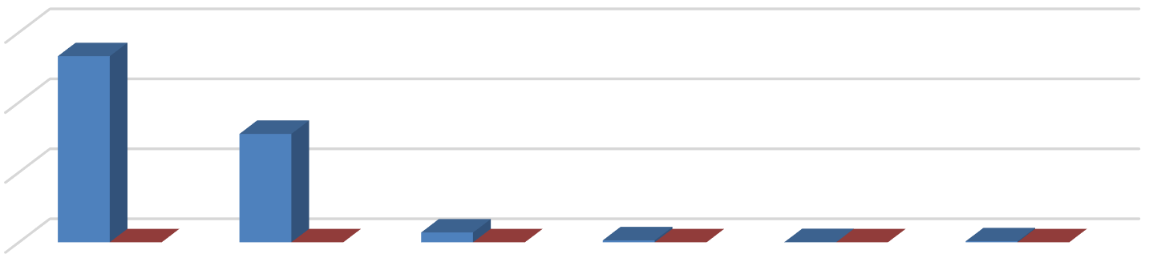Turnout times for EMS responses between the hours 8:00 AM and 4:00 PM, and the time distribution are shown in Figure 7.
Turnout Times by Hour of Day
0800 to 1600
1,500
1,330
1,000
775
500
26.24%
15.2… 70
1.3…
14 0.28% 1 0.02% 7 0.14%
0
0 to 1 min 1 to 2 min 2 to 3 min 3 to 4 min 4 to 5 min
> 5 min
Turnout Time in Minutes
Number of Runs

Figure 7

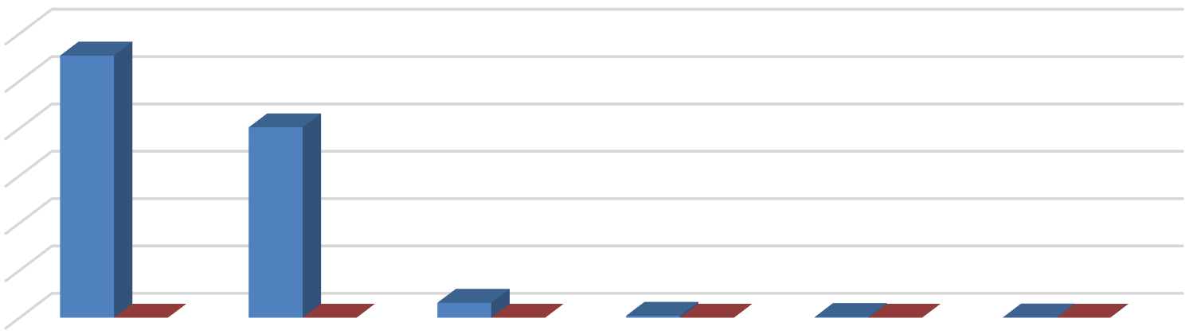Turnout times for EMS responses between the hours 4:00 PM and 11:59 PM, and the time distribution are shown in Figure 8.
Turnout Times by Hour of the Day
1600 to 2359
1,107
Turnout Time in Minutes
NUmber of Runs

1,200
1,000 | 804
800
600
400
200 | 21.8… |  | 15.86% 63 1.24% | 8 0.16% 3 |  | 0.06% | 1 | 0.02%
0
0 to 1 min |  | 1 to 2 min 2 to 3 min |  | 3 to 4 min | 4 to 5 min |  | > 5 min

Figure 8

Recommendation #6 - The fire department should establish a standard for Turnout Time and set the 90th Percentile for responder vehicle turnout time at 60 seconds for daytime and nighttime calls.

EMS Demand Distribution

In the demand analysis, SGR reviewed current and historical service demand for EMS services, and the temporal variation for the Grapevine Fire Department. Fire stations are generally well located to provide reasonable response time intervals. However, call volumes and demands for EMS service are not evenly distributed over a typical crew scheduling period of a 24 hour duty cycle. The temporal distribution of EMS demands for service will typically remain constant, from year to year, and is based on the nature and makeup of the community served.
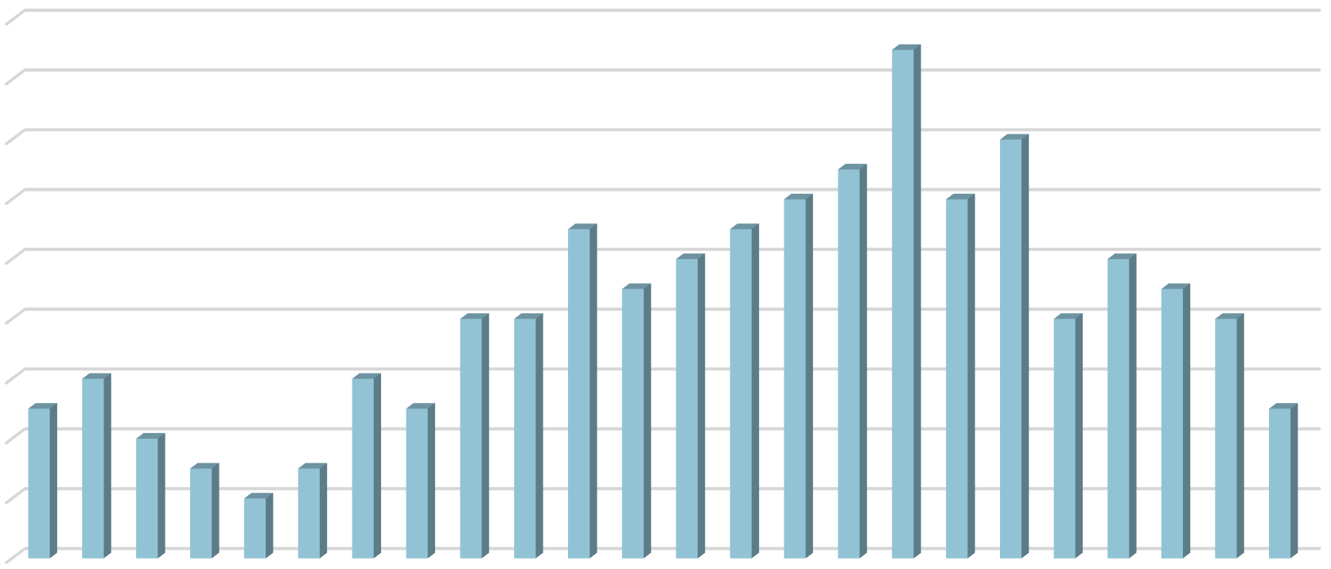EMS demands for service by hour of the day and day of the week can be examined to determine a relatively stable idea of when EMS call can be expected to be received. The average EMS Demand for Service for the three busiest months in both 2017 and 2018 were analyzed in order to understand the temporal variations likely to be experienced on any given day. In 2017, the 3 busiest months for EMS demands for service were in April, June, and September. The average number of calls per hour for the busiest three months in 2017 are shown in Figure 9.
Average EMS Service Demand by Hour
(Apr, Jun, Sep 17)
18
17
16
14
14
13
12
12
12
11
11
10
10
10
9
9
8 8 8 8
8
6
6
6
5
5
5
4
4
3
3
2
2
0
Time of Day
Number of Runs

Figure 9
0:00
1:00
2:00
3:00
4:00
5:00
6:00
7:00
8:00
9:00
10:00
11:00
12:00
13:00
14:00
15:00
16:00
17:00
18:00
19:00
20:00
21:00
22:00
23:00

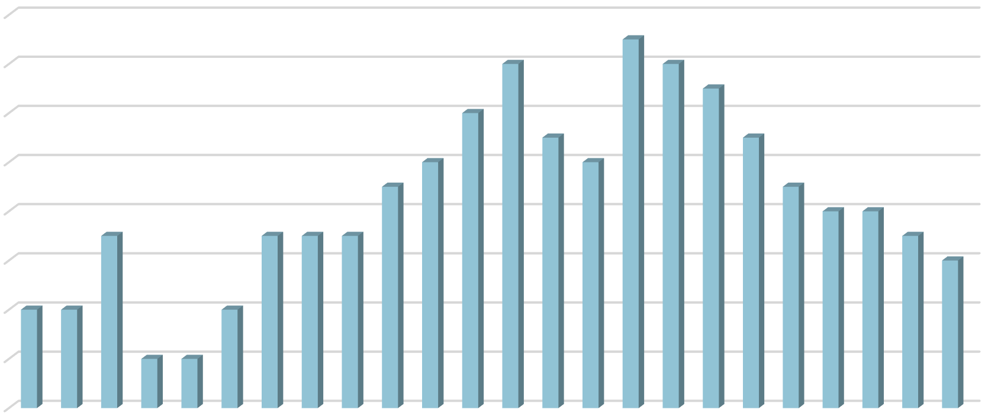In 2018, the 3 busiest months for EMS demands for service were in May, and December of 2018, and march of 2019. The average number of calls per hour for the busiest three months in 2018 and early 2019 are shown in Figure 10.
Average EMS Service Demand by Hour
(May & Dec 18, Mar 19)
16
15
14 14
14 13
12
12 11 11
10 10
10 9 9
8 8
8
7
7 7 7
7
6
6
4 4
4
4
2 2
2

0
Time of Day
Number of Runs

Figure 10
0:00
1:00
2:00
3:00
4:00
5:00
6:00
7:00
8:00
9:00
10:00
11:00
12:00
13:00
14:00
15:00
16:00
17:00
18:00
19:00
20:00
21:00
22:00
23:00

From looking at the change in demand by hour of the day for the preceding two year period, it can be seen that demand for EMS service is lowest from approximately 10:00 PM through the overnight hours, until approximately 6:00 AM. As the community awakens to go about its typical daytime activities, EMS demand volume increases during the eeliest daylight hours to a peak demand, usually between 10:00 AM and approximately 8:00 PM. After 8:00 PM, EMS call volume can be expected to decline as the community residents return home, or to its overnight accommodations and routine, to prepare for the next day. After tracking EMS demands by hour of the day, for a successive number of years, the department can expect that its demand for EMS calls for service will follow a similar pattern to traffic volume in the city, over the same 24 hour periods.

Similar to anticipated demands for EMS service by hour of the day, an analysis of historical demands for EMS service by day of the week may be conducted to develop a fairly consistent expectation of demands by the day of the week, on a year to year basis. A primarily residential community, supplemented by a corresponding amount of business and commercial development, will typically experience an increase in demands for EMS service as the week progresses.

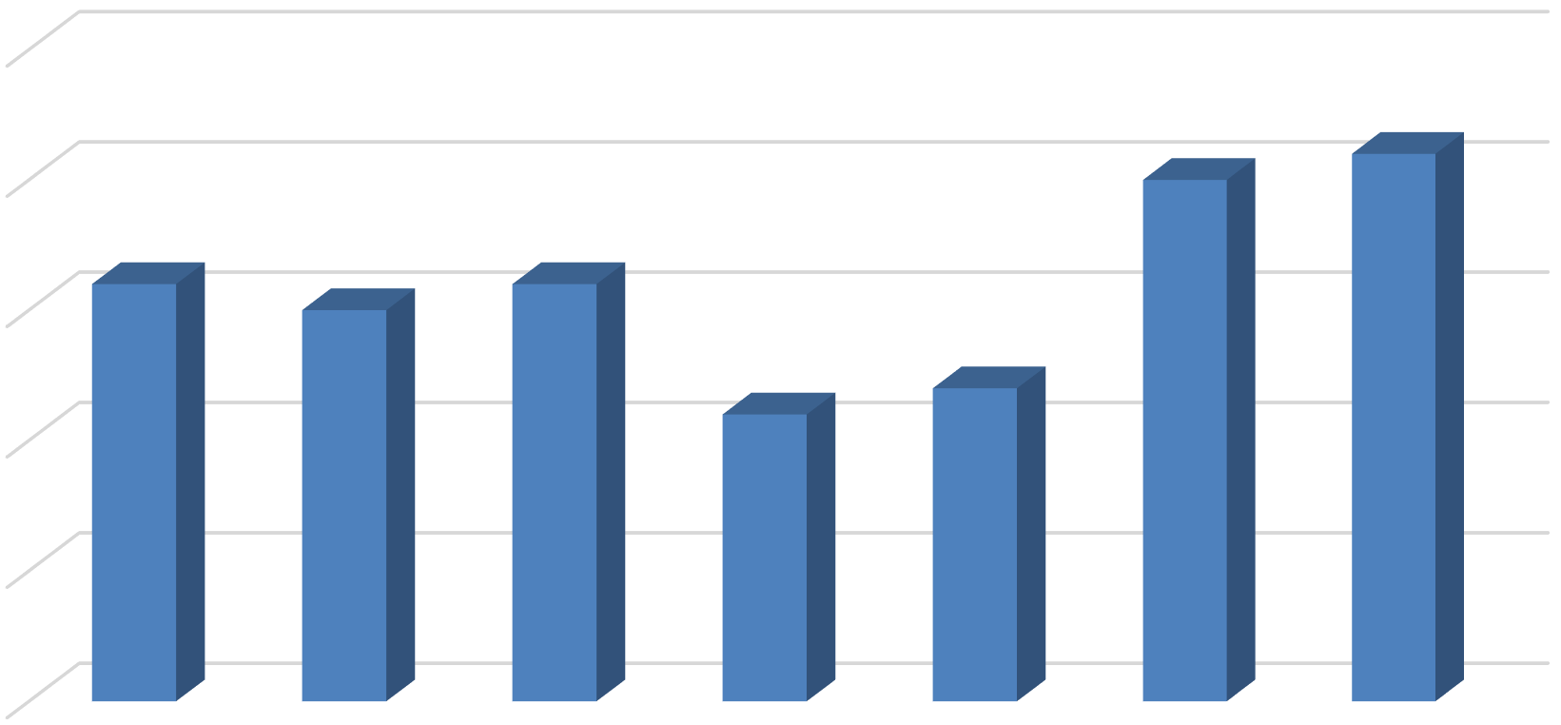Average EMS demands for service for the 3 busiest months in 2017 were examined. The average number of EMS requests for service for the months of April, June, and September in 2017 are shown in Figure 11.
Average EMS Demand by Day
(Apr, Jun & Sep 17)
25
21
20
20
16
15
16
15
12
11
10
5
0
Sun
Mon
Tue
Wed
Day of Week
Thu
Fri
Sat
Number of Runs

Figure 11

Similarly, a look at EMS demands for service for the 3 busiest months in the period between April 1, 2018 and March 31, 2019 indicated that The months of May and December of 2018, and March of 2019 were the busiest 3 months in the most recent 12 month period. The average number of EMS requests for service for the months of May and December of 2018, and, March in 2019 are shown in Figure 12.

Number of Runs

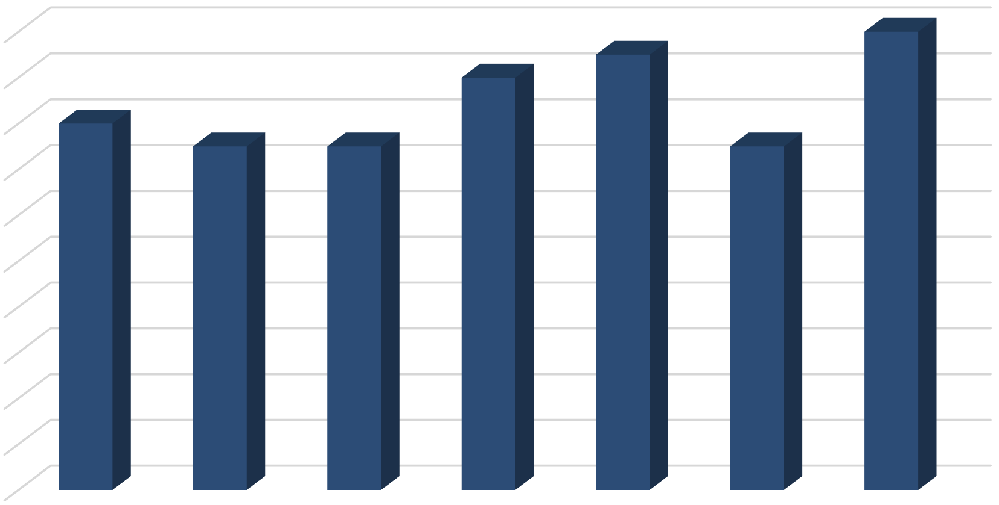Figure 12
Average EMS Demand by Day
(May & Dec 18,Mar 19)
20
20
19
18
18
16
16
15
15
15
14
12
10
8
6
4
2
0
Sun
Mon
Tue
Wed
Day of Week
Thu
Fri
Sat

EMS Demand Distribution by Unit

Data was examined to show the actual number of responses that were made by the fire department's three Medic Units. Call distribution management by ambulance is necessary in order to both balance the total EMS workload as evenly as possible on staff assigned to the ambulances, and also to ensure that the distribution of call does not adversely affect response times for those ambulances with a higher workload. This process also plays a role on ensuring maximum availability of the limited number of ambulances in the fleet. The assigned workload for each of the 3 medic units for the 12 month period of April 1, 2017 to March 31, 2018 is shown in Figure 13.
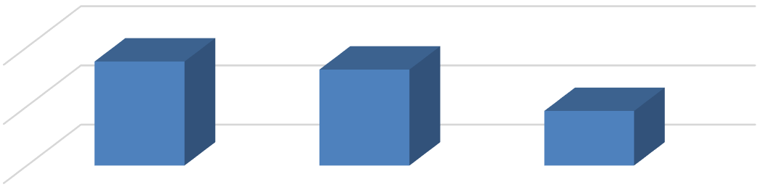
Number of EMS Runs by Unit Apr 17 to Mar 18
1756
1621
2000
922
1000

0
M-1
M-3
M-5
Figure 13

Emergency response assignments to each of the 3 Medic Units was also examined for each month in the 12 month period of April 1, 2017 to March 31, 2018. In the specific case of the Grapevine Fire Department, any Medic unit handling in excess of 186 calls for service in a one month period can be expected to potentially experience less than optimal performance As such, a monthly tracking of EMS calls for service for each medic unit is part of a sound demand management program. The number of EMS responses handled by Medic 1 in the 12 month period of April 1, 2017 to March 31, 2018, is shown in Figure 14.

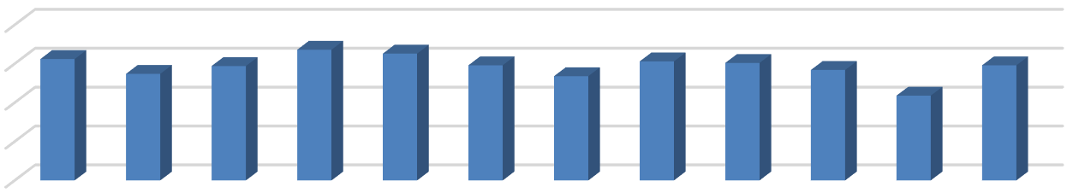
M-1 Apr 17 to Mar 18 Monthly Run Volume
200
150
100
50
0
156
137
147
168 163
148
134
153 151
142
148
109
2017 2017 2017 2017 2017 2017 2017 2017 2017 2018 2018 2018
Apr May Jun Jul Aug Sep Oct Nov Dec Jan Feb Mar
Figure 14

The number of EMS responses handled by Medic 1 in the 12 month period of April 1, 2017 to March 31, 2018, is shown in Figure 15.
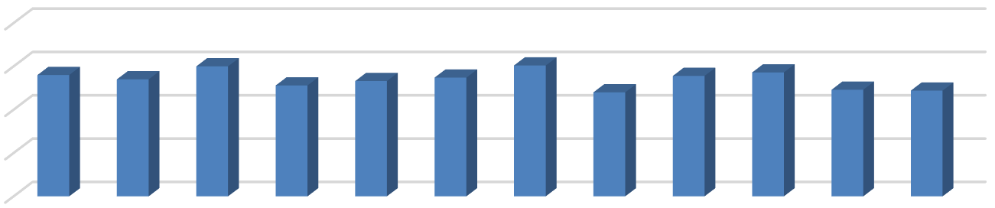
M-3 Apr 17 to Mar 18 Monthly Run Volume
200
150
100
50
0
140
135
150
128
133
137
151
120
139 143
123 122
2017 2017 2017 2017 2017 2017 2017 2017 2017 2018 2018 2018
Apr May Jun Jul Aug Sep Oct Nov Dec Jan Feb Mar
Figure 15

The number of EMS responses handled by Medic 1 in the 12 month period of April 1, 2017 to March 31, 2018, is shown in Figure 16.
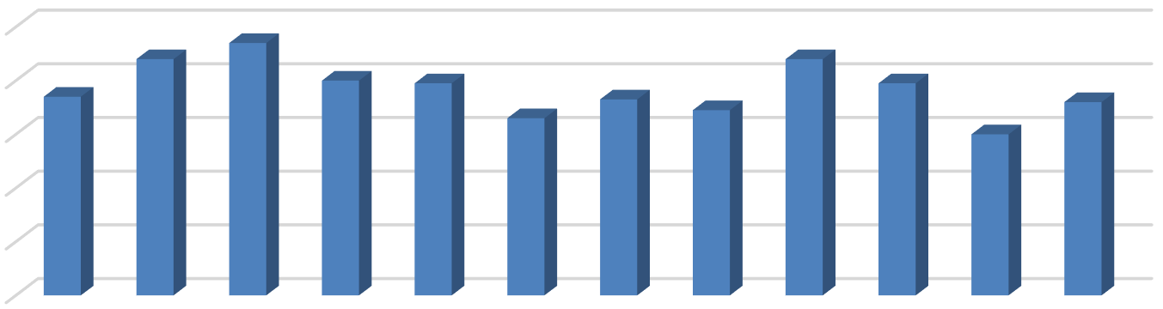
M-5 Apr 17 to Mar 18 Monthly Run Volume
100
80
60
40
20
0
88
94
88
74
80 79
79
66
73
69
72
60
2017 2017 2017 2017 2017 2017 2017 2017 2017 2018 2018 2018
Apr May Jun Jul Aug Sep Oct Nov Dec Jan Feb Mar
Figure 16

Emergency response assignments to each of the 3 Medic Units was also similarly examined for each month in the 12 month period of April 1, 2018 to March 31, 2019. It should be noted that in this 12 month period, Medic 1 was moved to Fire Station #2 in September of 2018, to better distribute the total volume of EMS calls for service to achieve a more equitable distribution of responses to each of the 3 available Medic Unit. (Specific date change was made? Feel free to correct or expand on the rationale for the move.)
While equitable call distribution among the various Medic units in the fleet. is a reasonable rationale for reassigning a response, this should not be done without also making a determination that the proposed move will not adversely affect the travel time component for the Medic unit being moved. The specific method to achieve that determination is discussed later in this report. The number of EMS responses by the ambulance fleet assigned to Fire Stations #1, #2, #3, and #5 for the 12 month period of April 1, 2018 to March 31, 2019 is shown in Figure 17.
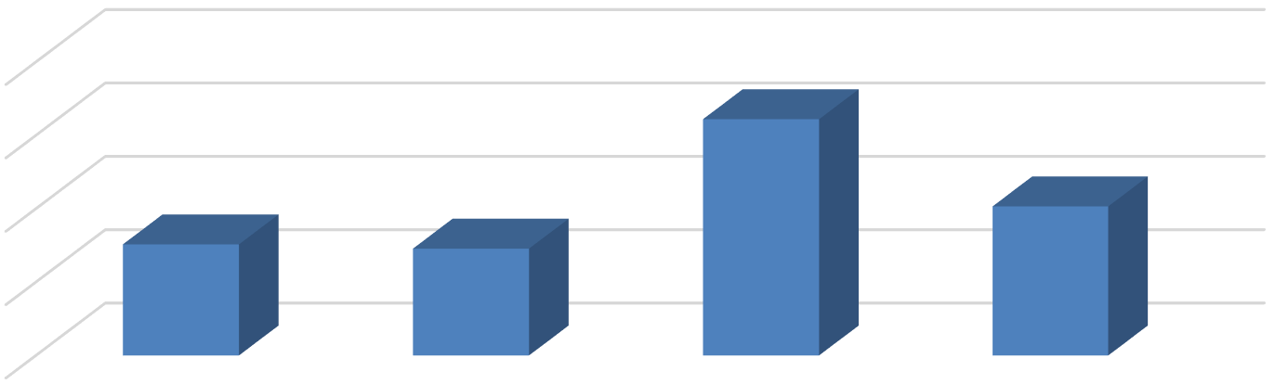
Number of EMS Runs by Unit Apr 18 to Mar 19
2000
1610
1500
1016
757
728
1000
500
0
M-1
M-2
M-3
M-5
Figure 17

The number of EMS responses handled by Medic 1/ Medic 2 for each month, in the 12 month period of April 1, 2018 to March 31, 2019, is shown in Figure 18.
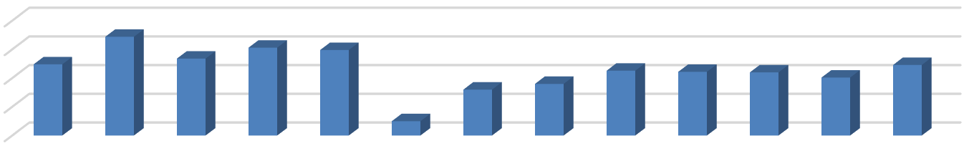
M-1/M-2 Apr 18 to Mar 19 Monthly Run Volume
200
150
100
50
0
172
124
134
153
149
123
80
90
113 111 110
101
25

2018 2018 2018 2018 2018 2018 2018 2018 2018 2018 2019 2019 2019
Apr May Jun Jul Aug Sep Sep Oct Nov Dec Jan Feb Mar M-1 M-1 M-1 M-1 M-1 M-1 M-2 M-2 M-2 M-2 M-2 M-2 M-2
Figure 18

The number of EMS responses handled by Medic 3 for each month, in the 12 month period of April 1, 2018 to March 31, 2019, is shown in Figure 19.
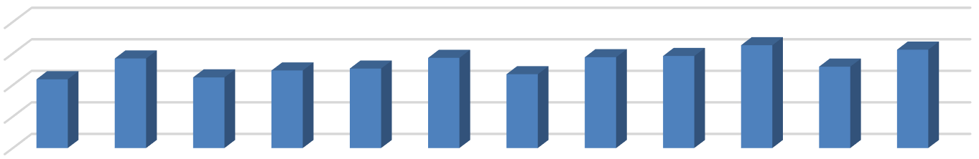
M-3 Apr 18 to Mar 19 Monthly Run Volume
200
150
100
50
0
109
142
112
123
126
143
117
144
146
163
129
156
2018 2018 2018 2018 2018 2018 2018 2018 2018 2019 2019 2019
Apr May Jun Jul Aug Sep Oct Nov Dec Jan Feb Mar
Figure 19

The number of EMS responses handled by Medic 5 for each month, in the 12 month period of April 1, 2018 to March 31, 2019, is shown in Figure 20.
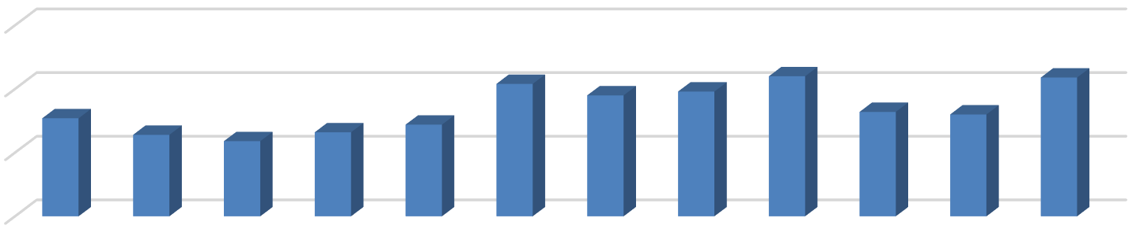
M-5 Apr 2018 to Mar 2019 Monthly Run Volume
150
104
95
98
110
109
100
77
64
82 80
59
66
72
50

0
2018 2018 2018 2018 2018 2018 2018 2018 2018 2019 2019 2019
Apr May Jun Jul Aug Sep Oct Nov Dec Jan Feb Mar
Figure 20

EMS Ambulance Transports

SGR requested data from the fire department for the types of EMS calls for service that are being currently handled by the department. The most frequent categories for emergency calls were:
- Injury
- Pain
- Weakness
- Respiratory Distress, and
- Abdominal Pain

A pre-hospital EMS system, such as that operated by the Grapevine Fire Department, is uniquely positioned to care for 9-1-1 patients and assist less- emergent patients with transport to the most appropriate care setting based on medical and social needs. Such an approach, today, is seen as being more and more appropriate and may ultimately lead to an ability to reduce the total cost of care, provide more patient-centered care and may reduce the burden on hospital based Emergency Departments, thus potentially enhancing the quality of care received by all patients.

Given the low-acuity nature of many patients being transported by a fire department based EMS system, , one may anticipate a better patient care experience when patients are either treated at the scene by EMS or taken to a clinic- based provider with shorter wait times than in the hospital Emergency Department. Recent studies of patient-centered medical homes (PCMH) have found significant reductions in hospital Emergency Department use, hospitalizations, and readmissions due to strong care coordination as well as increased quality of care. One PCMH pilot program in Seattle realized a 29 percent reduction in hospital Emergency Department use and an 11 percent reduction in ambulatory sensitive care admissions (i.e. admissions resulting from conditions that can be treated in an ambulatory care setting), resulting in $17 per patient per year of savings. In 2019 and beyond,

Fire Service based EMS systems may have many more alternatives to a traditional approach of transporting every patient to a hospital based Emergency Department, particularly with strong support by the system's Medical Director.
Encouraging the use of medically appropriate alternative care settings can reduce both hospital based Emergency Department visits and hospitalizations. This new approach and movement also has the potential to save significant resources in eliminating the need for more transport vehicles, additional employees and their resulting salary and fringe benefit costs. The is new approach also has the potential to make the use of existing transport vehicles and service provided to current demands much more efficient and effective to controlling both cost and patient outcomes.

SGR examined data provided by the fire department for patient transports for the most recent 12 month operating period, from April of 2018 through March of 2019. The number of patient transports by the most frequently observed primary impression are shown in Figure 21. It should be noted that not all of the patients treated in this time period necessarily were medically required to be transported to a hospital Emergency Department. There may have been numerous instances where an alternative to hospital transport may have been prudently taken, or have been a more reasonable alternative.

Transports by Primary Impression Apr 2018 to Mar 2019
500
452
400
321
300

200
150
143
139
100
15.19%
10.79%
5.04%
4.81%
4.67%
0
Injury
Pain
Weakness
Respiratory
Distress
Abdominal pain
Figure 21

Data was also examined for all ambulance calls handled by the Grapevine Fire Department for the 2 year period of April 2017 to March 31 of 2019, and is shown in Figure 22.

Ambulance Call Volume | Apr 17 to Mar 18 | Apr 18 to Mar 19
Total Run Volume | 5266 | 5065
Transports | 3008( 57%) | 2975 (59%)
Refusals | 1379 (26%) | 1235 (24%)
Disregarded prior to arrival | 879 (17%) | 855 (17%)

Figure 22

The data indicated that of the EMS responses handled for this two year period, that only 57% in the period of April 1, 2017 to March 31, 2018 were patients transported to a hospital Emergency Department, and 59% in the period of April 1, 2018 to march 31, 2019. It is also noted that in both time periods mentioned above, a total of 17% or, almost 1 in every 5 responses The ambulance was disregarded prior to arrival on the scene of the reported emergency. This would tend to indicate that better management of the dispatch process may result in fewer response assignments to the existing ambulance fleet, resulting on a

decrease of incidents where 4 or more ambulances are requested to respond to reported medical emergencies through the 9-1-1 PSAP.

Recommendation #7 - The Fire Department, working with the 9-1-1 PSAP dispatch agency should consider implementation of formal dispatcher training and certification as Emergency Medical Dispatchers, and operation of an Emergency medical Dispatch system to better manage the assignment of EMS responses by fire department personnel.

The safe and effective delivery of emergency medical services (EMS) starts with a consistent and professional provision of emergency medical dispatch. Its delivery through professionally trained emergency medical dispatchers (EMD) ensures the timely delivery of appropriate levels of medical care and life-saving that can have a dramatic impact on the care provided, and the best possible outcome for the patient. The consistent and predictable use of a uniform medically managed and supported EMD protocols ensures each 911caller receives EMD that is consistent with minimum required standards of care.
The best known and most popular EMD system in use by many fire departments, today, is the Medical Priority Dispatch System (MPDS), originally developed by Dr. Jeff Clawson and now controlled by the National Academy of EMD. The MPDS approach is seen by many EMS medical directors and fire chiefs as the most advanced and comprehensive EMD system available, today. The MPDS applies a systems approach to quality management of emergency medical dispatch activities and meets or exceeds all national standards and industry position statements related to dispatcher call handling.
As managed care organizations continue to reengineer health care through the realignment of economic incentives and delivery system design, an emergency medical dispatch system with locally developed medical protocols serves as the foundation of "access management" system solutions which are providing many new options for EMS service delivery in the community. An emergency medical dispatch system is essential for the safe and successful operation of access management activities from 9-1-1EMS communications. An emergency medical

dispatch system is, currently, the most advanced dispatch demand management system available to provide for a consistent approach to ensure that each 911 caller will receive a professional and complete assessment, resulting in an optimal system response.

Section II

Computer Aided Dispatch (CAD) Data Analysis for System Status Management

System Status Management (SSM) is the science of being in the right place with the right resource at the right time to meet the patient’s need. SSM takes the intelligence products of demand analysis of both time and space and matches manpower and availability to deploy a responder and transport capability as close to the patient as reasonable possible, particularly given the number of finite response and transport vehicles available in the typical fire department EMS system.

SGR examined EMS demands for service in the 3 busiest month from April 1, 2018 to March 31, 2019 to obtain a clear understanding of the specific number of times that the fire department received a request for EMS service, by both hour of the day and day of the month. This data examination was conducted for all EMS responses during the months of May and December of 2018, and March of 2019. The demand for EMS is displayed for every hour of May 2018, December of 2018, and March of 2019 on Figures 23, 24, and 25 respectively.

EMS Response Demand Analysis - May 2018
 | Tue 05-01 | Wed 05-02 | Thu 05-03 | Fri 05-04 | Sat 05-04 | Sun 05-06 | Mon 05-07 | Tue 05-08 | Wed 05-09 | Thu 05-10 | Fri 05-11 | Sat 05-12 | Sun 05-13 | Mon 05-14 | Tue 05-15 | Wed 05-16 | Thu 05-17 | Fri 05-18 | Sat 05-19 | Sun 05-20 | Mon 05-21 | Tue 05-22 | Wed 05-23 | Thu 05-24 | Fri 05-25 | Sat 05-26 | Sun 5-27 | Mon 05-28 | Tue 05-29 | Wed 05-30 | Thu 5-31
0000-0059 | 0 | 1 | 0 | 0 | 1 | 0 | 0 | 0 | 0 | 0 | 0 | 2 | 0 | 0 | 0 | 0 | 0 | 0 | 0 | 1 | 1 | 0 | 1 | 0 | 1 | 0 | 1 | 1 | 0 | 1 | 0
0100-0159 | 0 | 0 | 0 | 0 | 0 | 0 | 0 | 0 | 0 | 1 | 0 | 0 | 0 | 0 | 0 | 0 | 0 | 1 | 0 | 0 | 0 | 0 | 0 | 0 | 1 | 1 | 0 | 2 | 0 | 0 | 0
0200-0259 | 0 | 0 | 0 | 0 | 0 | 0 | 0 | 0 | 1 | 1 | 0 | 2 | 1 | 0 | 0 | 0 | 1 | 0 | 1 | 0 | 0 | 0 | 0 | 1 | 1 | 0 | 1 | 0 | 0 | 0 | 1
0300-0359 | 1 | 1 | 0 | 0 | 0 | 0 | 1 | 0 | 0 | 0 | 0 | 0 | 0 | 0 | 0 | 1 | 0 | 0 | 0 | 0 | 1 | 0 | 1 | 0 | 0 | 1 | 0 | 0 | 0 | 0 | 2
0400-0459 | 1 | 0 | 1 | 0 | 0 | 0 | 0 | 0 | 0 | 0 | 0 | 1 | 0 | 0 | 0 | 0 | 0 | 0 | 1 | 0 | 0 | 0 | 0 | 0 | 0 | 0 | 0 | 0 | 0 | 0 | 0
0500-0559 | 0 | 0 | 0 | 0 | 0 | 0 | 0 | 0 | 1 | 0 | 0 | 0 | 0 | 0 | 0 | 1 | 0 | 1 | 0 | 0 | 3 | 0 | 0 | 0 | 1 | 1 | 1 | 0 | 3 | 0 | 1
0600-0659 | 0 | 4 | 0 | 0 | 1 | 0 | 0 | 0 | 0 | 1 | 0 | 1 | 0 | 0 | 3 | 3 | 0 | 1 | 0 | 0 | 0 | 0 | 0 | 1 | 0 | 0 | 0 | 0 | 0 | 1 | 0
0700-0759 | 0 | 2 | 0 | 0 | 1 | 1 | 0 | 0 | 1 | 1 | 1 | 2 | 0 | 0 | 0 | 3 | 1 | 0 | 0 | 0 | 0 | 0 | 0 | 0 | 0 | 0 | 0 | 1 | 0 | 0 | 0
0800-0859 | 1 | 1 | 1 | 0 | 0 | 0 | 1 | 0 | 0 | 1 | 0 | 1 | 2 | 2 | 0 | 0 | 0 | 2 | 1 | 0 | 1 | 0 | 0 | 0 | 1 | 0 | 1 | 1 | 1 | 0 | 1
0900-0959 | 3 | 0 | 0 | 0 | 0 | 0 | 0 | 2 | 0 | 0 | 0 | 0 | 0 | 0 | 0 | 2 | 2 | 0 | 1 | 0 | 0 | 0 | 0 | 3 | 0 | 0 | 0 | 1 | 0 | 0 | 2
1000-1059 | 2 | 0 | 1 | 1 | 1 | 0 | 0 | 0 | 1 | 3 | 1 | 0 | 0 | 2 | 1 | 4 | 0 | 1 | 3 | 1 | 0 | 0 | 1 | 0 | 0 | 0 | 0 | 1 | 1 | 1 | 1
1100-1159 | 0 | 0 | 4 | 2 | 0 | 1 | 1 | 3 | 0 | 1 | 0 | 1 | 0 | 3 | 0 | 3 | 0 | 0 | 4 | 0 | 1 | 0 | 1 | 1 | 0 | 0 | 0 | 1 | 1 | 0 | 0
1200-1259 | 0 | 1 | 0 | 0 | 2 | 0 | 0 | 1 | 1 | 2 | 0 | 0 | 2 | 0 | 3 | 1 | 2 | 1 | 0 | 2 | 1 | 2 | 1 | 1 | 0 | 0 | 1 | 0 | 0 | 0 | 1
1300-1359 | 1 | 0 | 1 | 1 | 1 | 0 | 0 | 1 | 1 | 0 | 1 | 1 | 1 | 1 | 3 | 1 | 0 | 0 | 4 | 0 | 1 | 2 | 1 | 1 | 0 | 0 | 1 | 1 | 0 | 1 | 0
1400-1459 | 0 | 0 | 0 | 1 | 0 | 0 | 0 | 1 | 1 | 0 | 1 | 1 | 0 | 2 | 0 | 0 | 1 | 1 | 0 | 0 | 4 | 0 | 0 | 1 | 1 | 0 | 0 | 1 | 0 | 3 | 0
1500-1559 | 3 | 0 | 0 | 0 | 0 | 1 | 1 | 1 | 0 | 1 | 0 | 3 | 0 | 0 | 0 | 1 | 6 | 1 | 4 | 3 | 0 | 0 | 1 | 1 | 0 | 3 | 1 | 0 | 0 | 0 | 1
1600-1659 | 1 | 3 | 0 | 3 | 1 | 1 | 1 | 3 | 0 | 1 | 0 | 3 | 2 | 0 | 5 | 0 | 2 | 2 | 1 | 2 | 2 | 1 | 0 | 3 | 0 | 0 | 1 | 2 | 0 | 0 | 0
1700-1759 | 0 | 1 | 0 | 1 | 0 | 0 | 0 | 0 | 0 | 0 | 0 | 0 | 1 | 0 | 1 | 2 | 3 | 4 | 0 | 0 | 1 | 0 | 5 | 0 | 1 | 1 | 2 | 2 | 5 | 1 | 0
1800-1859 | 1 | 0 | 1 | 0 | 1 | 1 | 1 | 1 | 1 | 0 | 0 | 1 | 2 | 2 | 1 | 8 | 0 | 2 | 2 | 0 | 0 | 0 | 2 | 1 | 1 | 0 | 2 | 0 | 1 | 2 | 0
1900-1959 | 0 | 0 | 2 | 0 | 0 | 1 | 1 | 1 | 0 | 0 | 2 | 1 | 0 | 1 | 1 | 1 | 1 | 0 | 1 | 0 | 0 | 3 | 1 | 3 | 1 | 0 | 0 | 2 | 1 | 0 | 0
2000-2059 | 1 | 0 | 2 | 0 | 2 | 0 | 0 | 0 | 0 | 0 | 0 | 0 | 2 | 0 | 0 | 0 | 1 | 1 | 1 | 0 | 0 | 0 | 0 | 0 | 0 | 1 | 1 | 0 | 3 | 1 | 0
2100-2159 | 0 | 0 | 0 | 1 | 0 | 1 | 2 | 2 | 0 | 0 | 0 | 0 | 1 | 0 | 0 | 4 | 2 | 0 | 1 | 0 | 0 | 1 | 1 | 0 | 2 | 3 | 0 | 2 | 0 | 0 | 0
2200-2259 | 0 | 0 | 0 | 1 | 4 | 0 | 1 | 0 | 1 | 0 | 0 | 0 | 1 | 0 | 0 | 0 | 0 | 0 | 0 | 1 | 0 | 0 | 0 | 4 | 0 | 0 | 1 | 1 | 0 | 0 | 1
2300-2359 | 0 | 1 | 2 | 0 | 1 | 0 | 0 | 0 | 0 | 0 | 0 | 1 | 2 | 1 | 1 | 0 | 0 | 1 | 2 | 1 | 1 | 0 | 0 | 1 | 1 | 0 | 0 | 1 | 0 | 0 | 0
 | 15 | 15 | 15 | 11 | 16 | 7 | 10 | 16 | 9 | 13 | 6 | 21 | 17 | 14 | 19 | 35 | 22 | 19 | 27 | 11 | 17 | 9 | 16 | 22 | 12 | 11 | 14 | 20 | 16 | 11 | 11
Figure 23
Note: Hours where the demand was 3 ambulances are colored YELLOW Hours where the demand was 4 or more ambulances are colored RED

EMS Response Demand Analysis - December 2018
 | Sat 12-01 | Sun 12-02 | Mon 12-03 | Tue 12-04 | Wed 12-05 | Thu 12-06 | Fri 12-07 | Sat 12-08 | Sun 12-09 | Mon 12-10 | Tue 12-11 | Wed 12-12 | Thu 12-13 | Fri 12-14 | Sat 12-15 | Sun 12-16 | Mon 12-17 | Tue 12-18 | Wed 12-19 | Thu 12-20 | Fri 12-21 | Sat 12-22 | Sun 12-23 | Mon 12-24 | Tue 12-26 | Wed 12-27 | Thu 12-27 | Fri 12-28 | Sat 12-29 | Sun 12-30 | Mon 12-31
0000-0059 | 0 | 0 | 0 | 0 | 0 | 0 | 0 | 1 | 2 | 0 | 1 | 1 | 2 | 0 | 1 | 0 | 0 | 0 | 0 | 0 | 0 | 0 | 0 | 0 | 0 | 1 | 0 | 0 | 0 | 0 | 0
0100-0159 | 0 | 0 | 0 | 0 | 0 | 1 | 0 | 0 | 0 | 0 | 0 | 1 | 0 | 0 | 0 | 1 | 0 | 0 | 0 | 1 | 0 | 0 | 1 | 0 | 0 | 0 | 1 | 0 | 1 | 1 | 0
0200-0259 | 0 | 2 | 0 | 0 | 1 | 0 | 0 | 1 | 0 | 1 | 0 | 0 | 0 | 1 | 1 | 0 | 0 | 0 | 1 | 0 | 0 | 1 | 0 | 0 | 0 | 1 | 2 | 0 | 1 | 0 | 0
0300-0359 | 0 | 0 | 0 | 1 | 1 | 0 | 0 | 0 | 1 | 1 | 1 | 0 | 0 | 0 | 0 | 0 | 0 | 0 | 1 | 1 | 0 | 1 | 0 | 0 | 0 | 0 | 0 | 0 | 0 | 0 | 0
0400-0459 | 2 | 0 | 1 | 1 | 1 | 0 | 0 | 0 | 3 | 0 | 0 | 0 | 0 | 0 | 1 | 0 | 0 | 0 | 0 | 0 | 0 | 0 | 0 | 0 | 0 | 0 | 0 | 1 | 0 | 0 | 0
0500-0559 | 0 | 0 | 0 | 0 | 0 | 1 | 0 | 0 | 0 | 0 | 1 | 0 | 0 | 1 | 0 | 0 | 0 | 0 | 0 | 0 | 0 | 0 | 0 | 0 | 0 | 0 | 0 | 0 | 0 | 3 | 1
0600-0659 | 0 | 0 | 0 | 0 | 0 | 2 | 0 | 0 | 0 | 0 | 0 | 0 | 0 | 0 | 1 | 3 | 0 | 0 | 1 | 0 | 0 | 0 | 0 | 0 | 1 | 0 | 1 | 0 | 0 | 0 | 0
0700-0759 | 1 | 1 | 0 | 1 | 0 | 0 | 1 | 1 | 0 | 1 | 0 | 4 | 4 | 0 | 0 | 1 | 0 | 0 | 1 | 0 | 0 | 0 | 2 | 1 | 0 | 1 | 2 | 0 | 0 | 0 | 1
0800-0859 | 1 | 0 | 0 | 0 | 2 | 0 | 0 | 0 | 0 | 2 | 2 | 1 | 0 | 3 | 0 | 1 | 0 | 1 | 1 | 1 | 0 | 1 | 0 | 0 | 2 | 7 | 2 | 0 | 1 | 0 | 1
0900-0959 | 2 | 1 | 0 | 4 | 0 | 0 | 0 | 1 | 0 | 1 | 0 | 1 | 2 | 1 | 0 | 0 | 1 | 1 | 0 | 3 | 1 | 1 | 1 | 0 | 0 | 0 | 3 | 0 | 1 | 0 | 0
1000-1059 | 1 | 1 | 0 | 0 | 0 | 1 | 2 | 0 | 1 | 1 | 0 | 1 | 1 | 0 | 1 | 1 | 1 | 2 | 1 | 0 | 1 | 3 | 1 | 1 | 0 | 0 | 1 | 0 | 0 | 0 | 0
1100-1159 | 0 | 1 | 0 | 0 | 0 | 0 | 1 | 0 | 0 | 0 | 0 | 1 | 0 | 0 | 0 | 0 | 1 | 0 | 1 | 0 | 0 | 0 | 0 | 1 | 0 | 1 | 2 | 0 | 1 | 0 | 1
1200-1259 | 1 | 0 | 0 | 2 | 2 | 0 | 0 | 0 | 2 | 0 | 0 | 2 | 2 | 0 | 0 | 0 | 1 | 0 | 2 | 0 | 2 | 0 | 0 | 3 | 1 | 2 | 1 | 1 | 0 | 0 | 0
1300-1359 | 0 | 0 | 0 | 0 | 0 | 0 | 0 | 1 | 0 | 2 | 1 | 0 | 0 | 1 | 3 | 1 | 0 | 0 | 2 | 2 | 3 | 1 | 2 | 1 | 1 | 1 | 0 | 0 | 1 | 1 | 2
1400-1459 | 0 | 0 | 2 | 1 | 3 | 1 | 1 | 0 | 4 | 0 | 0 | 0 | 1 | 0 | 0 | 0 | 1 | 2 | 0 | 1 | 1 | 0 | 0 | 1 | 0 | 0 | 2 | 3 | 0 | 2 | 2
1500-1559 | 0 | 1 | 3 | 0 | 1 | 0 | 2 | 4 | 0 | 0 | 0 | 0 | 0 | 1 | 0 | 2 | 1 | 1 | 1 | 2 | 0 | 1 | 0 | 0 | 0 | 0 | 1 | 3 | 0 | 2 | 0
1600-1659 | 0 | 0 | 0 | 2 | 0 | 0 | 0 | 0 | 1 | 0 | 0 | 1 | 1 | 0 | 0 | 2 | 3 | 0 | 2 | 4 | 2 | 4 | 0 | 0 | 0 | 0 | 0 | 3 | 0 | 0 | 2
1700-1759 | 0 | 1 | 1 | 0 | 2 | 0 | 0 | 0 | 1 | 1 | 1 | 0 | 1 | 0 | 7 | 0 | 0 | 1 | 0 | 0 | 2 | 2 | 1 | 1 | 0 | 0 | 1 | 1 | 0 | 2 | 0
1800-1859 | 3 | 0 | 0 | 0 | 2 | 0 | 0 | 3 | 2 | 1 | 3 | 1 | 1 | 0 | 2 | 0 | 1 | 1 | 0 | 0 | 2 | 0 | 0 | 0 | 0 | 0 | 2 | 1 | 0 | 3 | 1
1900-1959 | 1 | 0 | 0 | 0 | 0 | 1 | 0 | 1 | 1 | 0 | 0 | 1 | 0 | 1 | 1 | 0 | 0 | 0 | 0 | 3 | 5 | 1 | 2 | 1 | 0 | 2 | 0 | 0 | 0 | 1 | 1
2000-2059 | 0 | 0 | 0 | 0 | 0 | 0 | 2 | 1 | 2 | 2 | 0 | 1 | 1 | 3 | 0 | 1 | 0 | 2 | 0 | 0 | 0 | 0 | 0 | 0 | 0 | 0 | 4 | 0 | 0 | 0 | 0
2100-2159 | 2 | 0 | 0 | 0 | 1 | 1 | 1 | 1 | 1 | 0 | 0 | 1 | 0 | 2 | 0 | 1 | 0 | 0 | 0 | 3 | 0 | 1 | 0 | 0 | 1 | 0 | 1 | 0 | 0 | 0 | 1
2200-2259 | 0 | 1 | 0 | 0 | 0 | 0 | 0 | 0 | 1 | 1 | 0 | 0 | 2 | 1 | 1 | 1 | 0 | 1 | 0 | 0 | 0 | 0 | 2 | 0 | 0 | 0 | 1 | 1 | 1 | 2 | 0
2300-2359 | 0 | 1 | 0 | 0 | 0 | 0 | 0 | 1 | 0 | 1 | 1 | 1 | 1 | 0 | 0 | 0 | 0 | 0 | 2 | 1 | 0 | 0 | 4 | 1 | 0 | 2 | 0 | 0 | 0 | 0 | 2
 | 14 | 10 | 7 | 12 | 16 | 8 | 10 | 16 | 22 | 15 | 11 | 18 | 19 | 15 | 19 | 15 | 10 | 12 | 16 | 22 | 19 | 17 | 16 | 11 | 6 | 18 | 27 | 14 | 7 | 17 | 15
Figure 24
Note: Hours where the demand was 3 ambulances are colored YELLOW Hours where the demand was 4 or more ambulances are colored RED

EMS Response Demand Analysis - March 2019
 | Fri 03-01 | Sat 03-02 | Sun 03-03 | Mon 03-04 | Tue 03-05 | Wed 03-06 | Thu 03-07 | Fri 03-08 | Sat 03-09 | Sun 03-10 | Mon 03-11 | Tue 03-12 | Wed 03-13 | Thu 03-14 | Fri 03-15 | Sat 03-16 | Sun 03-17 | Mon 03-18 | Tue 03-19 | Wed 03-20 | Thu 03-21 | Fri 03-22 | Sat 03-23 | Sun 03-24 | Mon 03-25 | Tue 03-26 | Wed 03-27 | Thu 03-28 | Fri 03-29 | Sat 03-30 | Sun 03-31
0000-0059 | 0 | 0 | 1 | 0 | 0 | 0 | 0 | 0 | 0 | 0 | 0 | 0 | 0 | 0 | 0 | 1 | 0 | 0 | 1 | 0 | 0 | 0 | 0 | 1 | 0 | 0 | 0 | 0 | 0 | 0 | 3
0100-0159 | 0 | 0 | 1 | 0 | 1 | 0 | 0 | 0 | 2 | 0 | 0 | 1 | 0 | 0 | 0 | 0 | 0 | 0 | 0 | 1 | 1 | 1 | 0 | 0 | 0 | 1 | 0 | 2 | 0 | 2 | 0
0200-0259 | 1 | 0 | 1 | 0 | 0 | 0 | 0 | 0 | 0 | 0 | 0 | 1 | 0 | 0 | 0 | 0 | 0 | 1 | 0 | 0 | 0 | 0 | 0 | 1 | 0 | 0 | 0 | 0 | 0 | 0 | 0
0300-0359 | 1 | 0 | 0 | 0 | 0 | 0 | 0 | 0 | 0 | 0 | 0 | 0 | 0 | 0 | 0 | 0 | 0 | 0 | 0 | 1 | 0 | 0 | 1 | 0 | 0 | 0 | 0 | 1 | 1 | 1 | 0
0400-0459 | 0 | 0 | 0 | 0 | 0 | 0 | 1 | 0 | 1 | 0 | 0 | 0 | 0 | 0 | 0 | 2 | 0 | 1 | 0 | 0 | 0 | 0 | 0 | 0 | 0 | 0 | 1 | 0 | 0 | 0 | 0
0500-0559 | 0 | 0 | 0 | 0 | 0 | 0 | 0 | 0 | 4 | 0 | 0 | 1 | 0 | 0 | 0 | 0 | 0 | 0 | 0 | 0 | 0 | 0 | 0 | 0 | 1 | 0 | 2 | 0 | 0 | 0 | 0
0600-0659 | 0 | 0 | 0 | 0 | 0 | 0 | 0 | 2 | 0 | 0 | 1 | 0 | 0 | 0 | 1 | 4 | 0 | 3 | 0 | 1 | 2 | 0 | 0 | 0 | 0 | 0 | 0 | 0 | 0 | 0 | 0
0700-0759 | 1 | 0 | 0 | 0 | 0 | 1 | 0 | 0 | 2 | 1 | 0 | 1 | 0 | 0 | 0 | 0 | 1 | 1 | 0 | 0 | 0 | 0 | 0 | 1 | 0 | 5 | 3 | 1 | 1 | 0 | 0
0800-0859 | 1 | 0 | 0 | 0 | 0 | 0 | 0 | 0 | 2 | 0 | 0 | 0 | 1 | 0 | 0 | 2 | 0 | 0 | 0 | 0 | 0 | 2 | 1 | 0 | 0 | 0 | 0 | 0 | 0 | 0 | 1
0900-0959 | 1 | 0 | 0 | 2 | 0 | 0 | 1 | 1 | 0 | 0 | 1 | 1 | 1 | 3 | 0 | 0 | 0 | 0 | 1 | 0 | 1 | 3 | 0 | 2 | 0 | 1 | 2 | 0 | 1 | 0 | 1
1000-1059 | 2 | 0 | 0 | 1 | 1 | 1 | 0 | 0 | 0 | 0 | 1 | 1 | 0 | 1 | 1 | 1 | 0 | 0 | 2 | 0 | 0 | 2 | 0 | 0 | 4 | 0 | 0 | 2 | 3 | 1 | 0
1100-1159 | 1 | 1 | 1 | 1 | 1 | 0 | 1 | 0 | 3 | 1 | 0 | 2 | 2 | 0 | 1 | 0 | 3 | 0 | 0 | 3 | 0 | 0 | 0 | 0 | 1 | 3 | 2 | 0 | 0 | 0 | 0
1200-1259 | 0 | 1 | 0 | 1 | 1 | 0 | 0 | 0 | 2 | 0 | 1 | 3 | 1 | 1 | 2 | 0 | 6 | 4 | 1 | 2 | 0 | 5 | 1 | 0 | 0 | 1 | 0 | 1 | 0 | 6 | 0
1300-1359 | 1 | 0 | 0 | 0 | 4 | 1 | 1 | 1 | 0 | 1 | 0 | 0 | 0 | 4 | 0 | 1 | 0 | 1 | 0 | 1 | 0 | 2 | 0 | 2 | 0 | 0 | 0 | 1 | 1 | 0 | 2
1400-1459 | 0 | 1 | 0 | 1 | 0 | 0 | 1 | 1 | 2 | 2 | 2 | 2 | 1 | 3 | 0 | 0 | 0 | 4 | 0 | 2 | 0 | 1 | 0 | 1 | 0 | 1 | 0 | 0 | 0 | 2 | 1
1500-1559 | 2 | 0 | 3 | 0 | 3 | 0 | 2 | 0 | 1 | 0 | 0 | 3 | 2 | 0 | 0 | 1 | 0 | 4 | 0 | 2 | 1 | 0 | 1 | 1 | 1 | 5 | 0 | 1 | 0 | 4 | 2
1600-1659 | 2 | 4 | 2 | 0 | 0 | 0 | 1 | 4 | 0 | 1 | 0 | 0 | 0 | 1 | 1 | 0 | 0 | 0 | 1 | 1 | 2 | 1 | 2 | 2 | 2 | 3 | 1 | 0 | 0 | 1 | 0
1700-1759 | 3 | 0 | 1 | 0 | 4 | 1 | 3 | 0 | 0 | 0 | 0 | 2 | 0 | 0 | 0 | 3 | 0 | 2 | 1 | 0 | 3 | 0 | 1 | 4 | 1 | 1 | 4 | 0 | 3 | 1 | 1
1800-1859 | 0 | 1 | 1 | 0 | 0 | 2 | 0 | 2 | 0 | 0 | 1 | 0 | 2 | 1 | 0 | 1 | 0 | 2 | 0 | 2 | 1 | 0 | 0 | 0 | 1 | 0 | 1 | 1 | 0 | 0 | 0
1900-1959 | 1 | 2 | 0 | 0 | 0 | 3 | 1 | 1 | 1 | 1 | 2 | 0 | 1 | 0 | 0 | 2 | 0 | 0 | 0 | 0 | 0 | 0 | 0 | 1 | 1 | 0 | 1 | 1 | 1 | 1 | 0
2000-2059 | 2 | 3 | 2 | 0 | 1 | 0 | 0 | 0 | 1 | 0 | 5 | 0 | 0 | 2 | 0 | 1 | 0 | 1 | 1 | 0 | 1 | 0 | 1 | 4 | 0 | 0 | 0 | 4 | 1 | 0 | 0
2100-2159 | 0 | 0 | 0 | 1 | 0 | 0 | 0 | 0 | 3 | 0 | 0 | 0 | 3 | 4 | 1 | 1 | 0 | 0 | 0 | 0 | 0 | 1 | 0 | 0 | 2 | 1 | 0 | 0 | 0 | 1 | 0
2200-2259 | 0 | 0 | 2 | 1 | 0 | 0 | 0 | 0 | 0 | 0 | 1 | 0 | 2 | 0 | 0 | 0 | 1 | 0 | 1 | 0 | 3 | 0 | 0 | 0 | 0 | 1 | 1 | 2 | 0 | 0 | 0
2300-2359 | 0 | 1 | 0 | 0 | 0 | 0 | 0 | 0 | 2 | 0 | 0 | 0 | 0 | 0 | 1 | 2 | 2 | 1 | 0 | 0 | 0 | 0 | 0 | 0 | 0 | 1 | 0 | 0 | 0 | 1 | 0
 | 19 | 14 | 15 | 8 | 16 | 9 | 12 | 12 | 26 | 7 | 15 | 18 | 16 | 20 | 8 | 22 | 13 | 25 | 9 | 16 | 15 | 18 | 8 | 20 | 14 | 24 | 18 | 17 | 12 | 21 | 11
Figure 25
Note: Hours where the demand was 3 ambulances are colored YELLOW Hours where the demand was 4 or more ambulances are colored RED

Data for this three high demand months indicated that there were demands for ambulances 3 times in the same hour on an average of 3.45% of the total hours over the 3 month period. Data for this three high demand months indicated that there were also demands for 4 or more ambulances for less than 3 % of the available hours. Specific demands for 3, and 4 or more ambulance for each of these three months is shown in Figure 26.

MONTH | Total Time Hours | Demand For 3  Ambulances | Percent of Fleet time | Demand 4 or more  Ambulances | Excess Demand
May 2018 | 744 | 29 | 3.90% | 16 | 2.15%
December2018 | 744 | 23 | 3.12% | 12 | 1.61%
March 2019 | 744 | 25 | 3.36% | 21 | 3.09%
TOTAL | 2232 | 77 | 3.45% | 49 | 2.28%
Figure 26

Data analyzed from this specific 3 month period would tend to indicate that the fire department does not need to add a 4th full time ambulance to its existing EMS fleet, particularly at an additional yearly cost of in excess of $1 million per year. There are other more economical options that the department has available such as placing an ambulance in service for high demand hours and staff the vehicle with existing staff on an overtime basis, assigning existing shift personnel during times when there are 27, or more, personnel on shift duty, or cross staffing a 4th demand ambulance with personnel from Truck 1, on an as needed basis (2 piece company, or swing staffed). SGR believes that there is an excellent opportunity to enhance Truck 1's responsibilities to provide the staffing for a 4th Demand Ambulance. Truck 1, particularly without the pumping capability of an engine or quint apparatus is an inappropriate design for a community the size of Grapevine. (currently underutilized to handle emergency demands) to include staffing a demand ambulance

Recommendation #8 - The Fire Department should identify numerous available options for staffing a 4th "High Demand Time" ambulance, other than adding 9 additional new shift fire fighters.

Recommendation #9 - The Fire Department should identify the advantages and disadvantages of each option identified in Recommendation #8 above, and based on minimum cost and greatest advantage, include a recommendation in the department's 2019-2020 budget submittal.

Recommendation #10 - The option selected from completion of the process recommended above should be backed up by current detailed data from the most recent 12 month period.

Recommendation #11 - The Fire Department should continue to manually monitor and examine Demand Ambulance demand needs on a continuing basis until they can complete the process in a more efficient automated manner.

Recommendation #12 - The Fire Department should reevaluate the validity of the option selected and implemented in recommendation # 10 above, and make periodic adjustments, as identified and needed, to both effectively (doing things right) and efficiently (doing the right things) in order to achieve the identified goal.

Technology Solution to Achieve EMS System Effectiveness

The department is currently challenged, by a limited administrative support staff to be able to dedicate a single person to perform ongoing data analysis for decision making. City Managers, City Council, and fire Chiefs must rely on quality data to make critical policy decisions about all issues, including fire and EMS operations. Public safety data are plentiful, but capturing and using the data can be challenging. Decisions relating to resource deployment, turnout times, response times, minimum staffing levels, funding and exposures, to name a few, are all necessary for sound decision-making in this day and age. Residents and other municipal stakeholders also expect their local government officials to use data in the efforts to show that tax revenue is being used in an efficient and cost- effective manner.

Recommendation #13 - A civilian data analyst employee should be added to the fire department support staff to gather and analyze available data, and identify additional data needs to support decision-making by the fire chief, city manager, and city council.
The current data analysis capability in the fire department is both inefficient and not capable of delivering the required level of detail for fire department management to make efficient and timely decision-making. The fire department has a source of valuable and detailed Computer Aided Dispatch (CAD) system data that it is not using to full advantage. Coupled with 21st century processing power, this CAD data can give the fire department the opportunity to use analytics and modeling to both better understand and predict performance capabilities for its limited fleet and personnel resources. These systems, initially developed in the mid-1990s, will deliver increased efficiency and responsiveness
to daily operations of the fire department. These systems, today, provide state-of- the-art tools that are absolutely vital to offering a powerful insight into a fire department's performance that will assist fire chiefs and managers to vastly improve their strategic decision-making.

Recommendation #14 - The Fire Department should enhance its ability to develop a dynamic overview of both its fire and EMS call volume through use of an Resource Deployment software analysis capability of CAD data that will provide a system-wide "Dashboard" view of current fire and EMS status to improve strategic decision-making.

EMS Staffing for a High Performance Fire-EMS System

The core basis for the request from the City of Grapevine to SGR was to evaluate the need for a 4th ambulance which has been previously requested by the Fire Chief. A review of this nature requires a close look at the current department organization and both the number of employees assigned to staff existing resources to carry out those duties and functions in an effective and efficient manner as possible. Part of that process also looks to determine if existing employees are in the right assignments to fulfill the various functions, and also to determine how quickly the organization can innovate, adapt, and overcome any anticipated and unanticipated events and issues that arise on short notice.
The current staffing of the Grapevine fire Department is shown on the following page in Figure 27.

GRAPEVINE FIRE DEPARTMENT
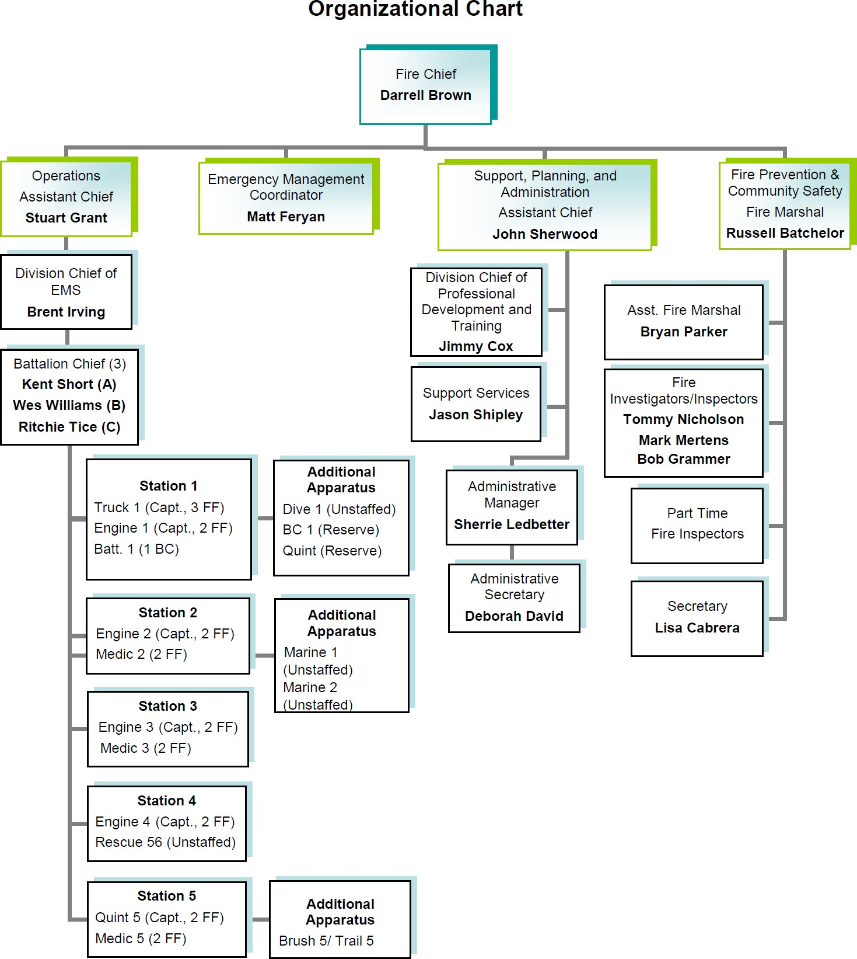

Figure 27
Source: GFD Annual Report for 2018
The staffing section of this report covers both operational. and administrative and support personnel deployment to meet EMS demands currently see by the Fire Department. A closer look was made on the specific emergency call demands seen in the past 4 fiscal years. Data was obtained from the Fire Department's Annual reports for 2014-2015 through 2017-2018 to determine the overall share of EMS demands against all responses by the department in each of those 12 month periods. The cumulative data from that process is shown in Figure 28.

GRAPEVINE FIRE DEPARTMENT DEMANDS FOR SERVICE VOLUME 2015-20118
 | 2014-2015 |  | 2015-2016 |  | 2016-2017 |  | 2017-2018
EMS | 3,680 | 65.86% | 3,900 | 66.05% | 4,432 | 71.66% | 4047 | 67.16%
Other | 1,908 | 34.14% | 2,005 | 33.95% | 1,753 | 28.34% | 1,979 | 32.84%
TOTAL | 5,588 | 100.00% | 5,905 | 100.00% | 6,185 | 100.00% | 6,026 | 100.00%
Figure 28

During the 4 year period examined, EMS service demands accounted for a low of 66.86% (FY 2014-2015) to a high of 71.66% (FY 2016-2017) of all response demands of the fire department. The fire department's organization chart and personnel assignment appears to replicate a business model that was common and prevalent in progressive fire departments during the late 1970's and early 1980's. The current organization chart brings into question whether changes in the operational environment of the Grapevine Fire Department make their current organizational staffing plan still relevant and appropriate to a city, state, and national fire service environment that has seen significant changes in the last 40-50 years. Specifically, fire incidents in the US are down more than 50% from the number of fire responses that were made in the 10970s. Conversely, fire departments respond to a rapidly growing volume of EMS demands for service, particularly over the last 30-40 years.

By looking at the current Fire Department organizational chart, one would get the impression that the major focus is only on response to fires and incidents other than EMS. For example, one observation made is that Truck 4 is a

In general terms, operational (emergency response) staffing of EMS response vehicles is reasonable and appears to be adequate for the period examined. However, given Grapevine’s somewhat unique risk profile based on recreational and resort/conference facilities, there may be a demonstrated challenge in effectively dealing with high risk, low frequency high risk critical care demands for service in both a timely and efficient manner. In addition, any significant increased population growth and service demand increases will further challenge

the ability to effectively handle low frequency, high risk demands for EMS service such as cardiac arrests and CVA (stroke) victims.

Immediate Staffing Needs
Based on the demand analysis and operations of the Grapevine Fire Department EMS system, the only immediate additional staffing that would be critical to the department would be for the addition of a civilian Staff Operations Data Analyst, as had been previously mentioned. This person would provide the Fire Department with the necessary date and information for sound fact-based decision-making which is critical for both efficient and effective operations.
Additional suggestions for staff enhancements are covered in more detail in the next section of this report. It should be emphasized that the addition of any new positions in the fire department must be based on both a realistic vision of what can be realistically accomplished with these new positions, and fact based expected benefits that are backed up by adequate data to justify both the needs and expected benefits to be accrued through these additional psitions.

Suggested Operational Adjustments
The following sixteen (16) items have been identified identified as needing to be examined for the potential to improve the overall efficiency and effectiveness of Fire Department EMS service delivery. These items are not necessarily listed in any prioritized order, but are just representative of elements found today in high- performance Fire-Based EMS operations.
- All chief officers, including the fire chief, should have a thorough state- of-the-art understanding of EMS service delivery through regular participation in educational programs such as Fire-Rescue Med (International Association of Fire Chiefs offering), or the EMS State of the Science: A Gathering of Eagles ( XXI was the 2019 offering) Sponsored by The University of Texas Southwestern Department of Emergency Medicine and Office of Continuing Medical Education. This offering is held annually in Dallas. More information can be found at: http://gatheringofeagles.us/2019/2019information.htm, or Follow @EaglesGather.
- The concept of Paramedic Engine Companies needs to be reevaluated and potentially adjusted as being a reasonable and effective service delivery tool in today's EMS environment. The majority of responses may be adequately handled by personnel trained only at the BLS level, but authorized to perform some advanced techniques.
- The department needs to establish or update its 5 year strategic plan to recognize the current state of the art in EMS service delivery. The plan should be formally reviewed and revised on an annual basis .
- a comprehensive Continuous Quality Improvement CQI program( QA/QI) to identify negative trends, implementation of refresher and remedial programs, build and implement Operative IQ, and conduct company level scenario and skills testing to improve skills and minimize EMS service delivery legal liability.
- Increase the emphasis and level of EMS training for both BLS and ALS fire personnel (contract basis or using department personnel).
- Consistent with the volume and distribution of EMS call for service in the department, examine the benefits of establishing a specific EMS

promotional route in the department, or modifying the current promotional process to put additional emphasis on EMS skills and capabilities.
- Increase Engine Captain EMS triage capabilities to better manage the need for ambulance transport (disregard transport vehicle a.s.a.p. after arrival when not needed).
- The Assistant Chief of Operations should have designated responsibilities and involvement in EMS system demand management
- The Fire Department needs to clearly understand the cost of service for EMS delivery (both capital and operating cost. e.g. cost per response, cost per mile, etc.).
- Revise resource dispatch protocols to better match resource(s) required to nature of the specific request for fire and EMS service.
- The Fire Department should manage its emergency vehicle response risk through fewer Code 3 responses (Priority 1 only)
- Response time goals should be reset to match required performance for Priority 1, and lower priority responses..
- With the support and encouragement of the City Manager and City Council, the Fire Department should examine the potential benefits for achieving Fire and EMS Accreditation (Commission on Accreditation of Ambulance Services (CAAS) and/or the Commission for Fire Accreditation International (CFAI)
- The Fire Department, working closely with the City Manager and City Council, should develop a formal and endorsed written MICU Replacement Program (4 to 6 years suggested maximum) life cycle to ensure at least 90% fleet availability (e.g. with a 4 or 5 fleet of ambulances, one ambulance should be replaced per year with 3 years being operated as a daily front line unit, and a rotation to 2 final years as a reserve or Demand Schedule Ambulance).
- The Fire department, working closely with the department's EMS Medical Director should examine the feasibility and benefits to the use of Advanced Practice Paramedic positions (Existing or added staff) to be used for training, education, administrative, clinical duty, (i.e. research and development of new devices, medications, protocols, termination of resuscitation protocol, refusal protocol, development of the community paramedic concept, manage risk on patient refusal, etc.). These positions could be used as assigned shift paramedics during high demand days and hours and respond to Priority 1 calls with an SUV response vehicle for on scene support. The position would not change the on-scene command authority.
- The Fire Department should examine the potential benefits to using EMS Squads at high response stations. These smaller response vehicles would be cross-staffed by Engine Company personnel to reduce wear and tear on Engines.

What’s Necessary to Ensure Successful Improvement?

Every EMS organization is unique, with varying degrees of access to different levels of resources and manpower. Because of this, they all have different capabilities, and can expect varying standards for performance.

With this in mind, the Grapevine Fire Department should measure itself by their own, distinct goals. What would be considered successful for a well-staffed and well-funded agency might be unrealistic for a small agency with fewer resources.

Any one of the following issues can prevent organizations from committing to process improvement:

  - A lack of people with the right skills to dedicate to system performance analysis;
  - A lack of funding to purchase the right tools; and
  - A lack of access to the data necessary to make valid assessments.

High-performance Fire-EMS organizations must use measurements and analytics to allocate resources and manage quality improvement. They invest in their organizations with the goal of developing a culture that turns to metrics and data analysis for system improvement, capability and performance. These organizations usually are committed to attaining the following:

  - People with relevant knowledge and skills to analyze the data;
  - Committed investments for tools to support process improvement; and
  - Access to data with transparent availability and full cooperation of data owners.

Current Challenges in EMS System Improvement

Under a contract with the U.S. Department of Homeland Security (DHS), DataTech911 conducted a study in which more than 100 EMS agencies were interviewed and surveyed. Survey results revealed the following:

  - The need to categorize KPIs (e.g., financial performance, response improvement, patient outcomes, and workforce management);
  - The need for agencies to select and customize KPIs relevant to their organization; and
  - The need for demographic stratification (i.e., wilderness, rural, suburban or urban). Based on the area covered by an agency, different KPI thresholds should be defined for each category.

In order to ensure a clear understanding of the specific challenges that exist, or are likely to be encountered, a thorough process must be conducted to identify the required, or desired, operating parameters and current boundaries that inhibit moves to a more dynamic EMS system. During the required survey process, the following challenges and process issues may be clearly identified:

  - Data is rarely available at the correct time and in the right form and format;
  - Data collecting processes affect the results (e.g., is time on scene based on arrival on scene or patient contact);
  - Mixing incident data for special events (i.e., units staged on-site) with emergency 9-1-1 calls can affect analysis. When calculating KPIs such as unit hour utilization, cost per call, or response times, mixing special events calls with emergency calls can skew the results; and
  - Most organizations don’t own all their data stores (e.g., Fire EMS organizations rely on another agency or county-owned computer-aided dispatch for incident information).

Other roadblocks that agencies frequently encounter include:

  - Date and time stamps: Are they accurate?
  - Software mapping issues: Are different pieces of software “speaking” to each other?
  - Element completion: Are important stages in the process being properly recorded?

  - Null/unknown values in tracking system: Are all elements of necessary data being collected? How are Null/unknown values accounted for in the overall metrics?

Section 3

Creating a High Performance Fire EMS Response organization
The current conditions analysis and system demand projections form the foundation from which SGR has developed strategies for the delivery of services in Grapevine for the future.

This section cites multiple future system model modifications, included both short-term and long-term initiatives that are identified in the interest of improving and maintaining future system integrity. Use of these concepts will provided clear and concise guidance regarding how the Fire Department can assess critical tasking, risk analysis, and staffing performance from which response time performance objectives can be established, monitored, and revised, as needed, as conditions change over time.

The Concept of Community Risk Reduction

A progressive fire department, today, should be well on their way to having conducted a comprehensive community survey to develop a strategic approach of the delivery of both fire and EMS service to their community. The current benchmarking process to accomplish that plan is through the development of a Community Risk Reduction (CRR) algorithm to both manage and minimize call demand and consequences in the community.

Community Risk Reduction (CRR) is a process to identify and prioritize local risks, followed by the integrated and strategic investment of resources (emergency response and reduction and prevention) to reduce their occurrence and impact. Typically, Community Risk Reduction programs use a six-step approach towards development.

  - Step 1: Identify Risks
  - Step 2: Prioritize Risks
  - Step 3: Develop Strategies & Tactics to Mitigate Risks
  - Step 4: Prepare the CRR Plan
  - Step 5: Implement the CRR Plan
  - Step 6: Monitor, Evaluate, and Modify the CRR Plan

A Community Risk Assessment Guide has been developed to help fire departments and other organizations to conduct a basic or more complex assessment of risks within their community. Ultimately, the results of the risk assessment can be used to develop a CRR plan. A copy of the Guide can be downloaded, at no cost, at:
http://strategicfire.org/wp-content/uploads/2016/04/Community-Risk- Assessment-Guide-v1.5.pdf

The guide describes various processes and methods used in the first two steps of developing a CRR plan: Identification of Risks and Prioritization of Risks. This is followed by a description on how to put it all together, with an example of how a risk assessment document might be compiled. The guide also includes

a comprehensive list of additional resources that can be utilized in developing a risk assessment.

How Many Resources Do We Really Need?

The question that is posed to a fire chief most frequently, when discussing needed staffing and resources (Fleet vehicles) is - How many ambulances and Fire apparatus do we really need to deliver a reasonably expected level of performance. The answer to that question is not as easily answered as might be expected and typically is more along the lines of: "It depends..." It will depend on what the volume of emergency calls is for a given community and how many resources (most typically response vehicles) can and does the community provide to meet their expectations. Generally speaking, both the International Association of Fire Chiefs (IAFC) and the International Association of Fire Fighters (IAFF) have provided an opinion that a fire chief may use for guidance. The IAFC recommendation is an ambulance or fire vehicle, and staffing, should not reasonable be expected to be responding to emergency calls more than 30% of its time. The IAFF, probably not surprisingly, sets their recommendation at 25% of the time. On the surface, it may appear that these two recommendations are fairly close. In actuality, complying with the IAFF recommendation, instead of the IAFC recommendation, will increase the community's cost by a factor of 20%.
With the staffing of one ambulance on a 24 hour per day, 365 day a year basis, at an annual cost of at least $1 million, or an engine or ladder vehicle at an annual cost of $1.5 to $2 million, the overall total cost to the community for each new vehicle and crew, can rise, and accumulate, pretty quickly.
The apparatus and staffing model for the typical career fire department places the same amount of vehicles and personnel in strategically located fixed locations throughout the community on a 24 hour per day, 365 day per year basis. Yet the demands for service are not the same during that same 24 hour period, and that complicates the process of determining just how many resources should a fire department have available for each hour of every day during the year. Depending on the number of vehicles that any individual community is able to financially support, there will be a few times on various days during any given year when demands for service will deplete all available resources. In this instance, fire departments will usually resort to calls for mutual aid from surrounding communities who may still have unassigned crews and vehicles. Most of the time,

however, using this model, during any given 24 hour period there will be a surplus of vehicles and staff who are unassigned and in a "standby" mode of readiness to respond on a moment's notice. The typical staffing model availability chart for a typical community with a nature similar to Grapevine is shown in Figure 29.

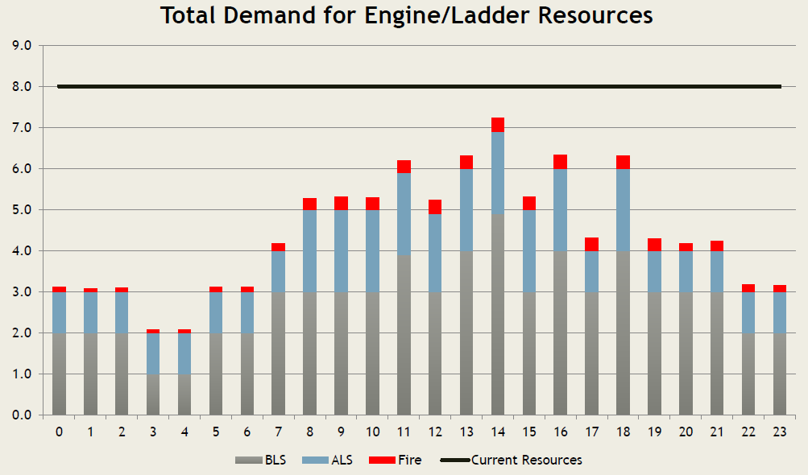

Figure 29

Looking at Figure 29 as an example the level of resources available is represented on the chart by the solid black line. The black line is typically constant for each day of the year. The dynamic part of the problem is that the "sine" shaped curved line will vary from day to day, meaning that sometimes the community will be required to call for adjacent community "Mutual Aid" when the hourly demand exceeds the available level of resources, during that specific hour on that specific day. The typical demands for every system is always dynamic and in motion, to some extent, and is influenced by a number of different factors specific to any given community. In order to answer the question of How many ambulances, fire trucks, etc. do we need, the community must decide how much risk are they

willing to accept for running out of resources from time to time? This is referred to as the community's Risk Tolerance. The "Risk Tolerance" for any given community is a public policy decision rather than a decision that will be driven either by a specific scientific process or calculation. The Risk Tolerance decision should never be the decision of fire chief or a fire department. This is exclusively, and rightly, a decision for the elected representatives of the residents of the community.
Up to this point in this specific discussion we have been speaking in terms of application of theory. In reality, a fire chief will be asked by his/her city manager and/or city council to provide counsel and guidance in making this Risk Tolerance policy decision. Fortunately for a fire chief, there is a process that can be used to provide the elected officials adequate guidance to determine an ultimate answer to the posed question for the needed number of resources. This process is call Unit Hour Utilization (UHU).

How to Calculate Unit Hour Utilization

The process to determine Unit Hour Utilization is accomplished through conducting a process called Unit Hour Analysis (UHA). This analytical process may be accomplished for both EMS and fire resources. SGR has not been tasked with looking at fire demands for the Grapevine Fire Department as a part of this study. The depth of data needed and an efficient process to calculate specific Unit Hour Utilization data for the Fire Department's three current ambulances was not accomplished to provide a specific UHU rate for each specific EMS vehicle that the department currently operates. The Demand analysis has been used as a more expedient alternate to the UHU calculation process. However, a reasonably accurate estimate of the EMS ambulances' Unit Hour Utilization was able to be performed with the date used in the Demand analysis. Before discussing those calculations, one must understand a few basic definitions of what the data shows.
To fully understand the information contained in the analysis it is prudent to provide a few definitions to assist in understanding the impact of the UHA.

A unit hour is equal to one hour of service by a fully equipped and staffed ambulance available for dispatch or assigned to a call. For ambulance services with average turnaround times which are greater than one hour, adjustments can be made to the listed formulas to achieve more accurate estimates.

Utilization is a measure of productivity, which compares the available resources (i.e. unit hours) with the actual amount of time those units are being utilized for patient treatment and transport or productive activity. This measurement is calculated to determine the percentage of unit hours actually consumed in productivity compared with the total staffed unit-hours.

If we use the data gathered in Figure 13 for EMS run volume for the three Medic ambulances during the period of April 1, 2017 to March 31, 2018, and using an assumption that each medical response averages a time Out-of-Service (OOS) of approximately 1 hour, we can calculate a UHU for each of the Medic units. That calculation and the resulting chart showing the UHU rate for each of the Medic ambulances is shown in Figure 30.

Grapevine Ambulances- Estimated Unit Hour Utilization
April 1, 2017 to March 31, 2018
 | Medic 1 | Medic 3 | Medic 5
Calls for Service | 1,756 | 1,621 | 922
Period Hours Staffed | 8,760 | 8,760 | 8,760
Unit Hour Utilization Rate | 20.05% | 18.50% | 10.53%
Figure 30

Having made an approximate UHU rate calculation for each of the three Medic units in the 12 month period, what do the numbers indicate? To determine that SGR referenced a document entitled: Calculating your EMS Service's "Average Cost of Service" and "Unit Hour Analysis". This document was developed by J.R. Henry Consulting, Inc. in 2011. It remains the definitive guide currently. A full copy of the document including suggested worksheets to conduct the analysis is included in Appendix A of this report.

Unit Hour Analysis Summary

Once the UHU rate has been calculated using validated data, an EMS agency can easily determine whether the Medic unit workload is above, at, or below recommended utilization. A direct comparison and correlation of UHU between separate EMS organizations is difficult as utilization rates are dependent on a number of other mitigating factors such as the presence of response time standards, shift length, overall time or length of transports; impact on employee wellness and safety, transport times and medical facility turnaround times as well as a variety of other operational and administrative issues. Typically, EMS organizations strive for the highest utilization rates possible, with optimal overall utilization rates being considered in the .50 - .55 range. J.D. Henry Consulting, Inc. utilizes the following general scale when evaluating EMS organization overall utilization and proficiency.

Unit Hour Utilization Rate:
.55 - .45 – Optimal Utilization
.45 - .35 – Above Average Utilization
.35 - .25 – Average Utilization
.25 - .15 – Below Average Utilization
.15 - .01 – Poor Utilization
Figure 31

Recommendation #15 - The Fire Department, using validated CAD data for time spent while engaged in emergency response activities, should calculate the Unit Hour Utilization (UHU) rate, on an ongoing and continuous basis, for all fire and EMS response resources.
Recommendation #16 - The Fire Department, using the UHU rates identified in Recommendation #15, should work toward balancing the resource workload as much as possible to achieve maximum benefit to the members of the department and the community.

Section 4

Establishing Key Performance Indicators to Assist with EMS Critical Decision- Making
The following information is included in this report in order to provide specific guidance to the Fire Chief and Command Staff of the Fire Department with a suggested road map to develop a database that is currently deficient in the department. The information had been excerpted from EMS Insider, and has not been edited or modified from the original version. EMS Insider is available by digital subscription from The Journal of Emergency Medical Service at JEMS.com. Subscribers receive a monthly Insider e-newsletter delivered right to their inbox. The newsletter regularly provides legal advice, management strategies, research reviews and executive-level information packaged in a convenient, easy-to-print format. If the Fire Department is not a current Insider subscriber, a subscription request can be made at: emsinsider.com . Weekly and Monthly newsletters, in addition to a wealth of additional EMS guidance is available at no cost to the subscriber.

Key Performance Indicators: What to Measure & Why

Wed, Feb 21, 2018
By Michael J. Salonish , Swati D. Allen

This is the first in a series of articles about performance measurement and improvement. Part 2, "Where Do We Start?" can be found here. Future articles will be featured in EMS Insider and will present case studies about specific EMS agencies' improvement efforts.

A key performance indicator (KPI) is a measurable value that demonstrates how effectively an organization is achieving key objectives.

KPIs evaluate the success of an organization or of an activity in which it engages. In many cases, success is simply the repeated, periodic achievement of some level of an operational goal. Depending on the organization, the goal may be having zero product defects, achieving 10 out of 10 in customer satisfaction, or any other type of desirable organization outcome. In cases where these goals seem far off and difficult to achieve, success is defined in terms of making progress toward strategic goals.

Because of the role that KPIs play in the trajectory of an organization, it’s important to choose the right ones. Choosing the right KPIs to measure performance improvement requires a good understanding of what’s important to the organization.

An influential article focused on management goals considers the critical nature of creating objectives while also recognizing the difficulty of setting the right goals.¹ This paper explained that, ideally, any organizational goal or objective should be “SMART:”

  - Specific: Target a specific area for improvement;
  - Measurable: Quantify or at least suggest an indicator of progress;
  - Agreed upon: Specify who will do it;
  - Realistic: State what results can realistically be achieved, given available resources; and
  - Time-related: Specify when the results can be achieved.

Key stages in an organization's performance improvement efforts.

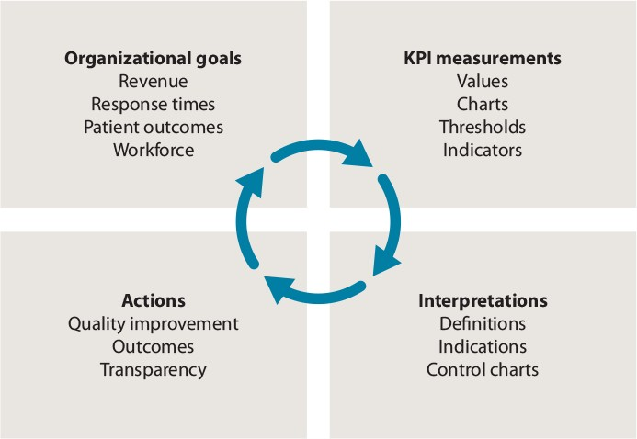

Figure 31

What’s Necessary to Ensure Improvement?

Every EMS organization is unique, with varying degrees of access to different levels of resources and manpower. Because of this, they all have different capabilities, and can expect varying standards for performance.

With this in mind, EMS organizations should measure themselves by their own, distinct goals. What would be considered successful for a well-staffed and well- funded agency might be unrealistic for a small agency with fewer resources.

Any one of the following issues can prevent organizations from committing to process improvement:

  - A lack of people with the right skills to dedicate to system performance analysis;
  - A lack of funding to purchase the right tools; and
  - A lack of access to the data necessary to make valid assessments.

High-performance organizations use measurements and analytics to allocate resources and manage quality improvement. They invest in their organizations with the goal of developing a culture that turns to metrics and data analysis for system improvement, capability and performance. These organizations usually are committed to attaining the following:

  - People with relevant knowledge and skills to analyze the data;
  - Committed investments for tools to support process improvement; and
  - Access to data with transparent availability and full cooperation of data owners.

Current Challenges in EMS

Under a contract with the U.S. Department of Homeland Security (DHS), DataTech911 conducted a study in which more than 100 EMS agencies were interviewed and surveyed. Survey results revealed the following:

  - The need to categorize KPIs (e.g., financial performance, response improvement, patient outcomes, and workforce management);
  - The need for agencies to select and customize KPIs relevant to their organization; and
  - The need for demographic stratification (i.e., wilderness, rural, suburban or urban). Based on the area covered by an agency, different KPI thresholds should be defined for each category.
  - During the interview and survey, process the following challenges and process issues were reported:
  - Data is rarely available at the correct time and in the right form and format;
  - Data collecting processes affect the results (e.g., time on scene is based on arrival on scene or patient contact);
  - Scheduled calls left in the dispatch queue for days can invalidate emergency response time information. If a scheduled call is left in the dispatcher’s queue, it can grossly affect the average dispatch time to the point where the measure has no meaning for emergency calls;
  - Mixing incident data for special events (i.e., units staged on-site) with emergency 9-1-1 calls can affect analysis. When calculating KPIs such as unit hour utilization, cost per call, or response times, mixing special events calls with emergency calls can skew the results; and
  - Most organizations don’t own all their data stores (e.g., local EMS organizations rely on county-owned computer-aided dispatch for incident information).

Other roadblocks that agencies frequently encounter include:

  - Date and time stamps: Are they accurate?
  - Software mapping issues: Are different pieces of software “speaking” to each other?
  - Element completion: Are important stages in the process being properly recorded?

  - Null/unknown values in tracking system: Are all elements of necessary data being collected? How are Null/unknown values accounted for in the overall metrics?

Where to Start?

Taking the first step to improve your organization’s performance can be daunting, and often great successes can come from taking things in a step-by-step manner.

To focus the performance improvement effort, start by taking the following steps:

- Identify an organization goal.
- Use the SMART approach to define a relevant KPI.
  - Determine the required data and how to collect it.
  - Collect the data and calculate the KPI.
  - Analyze the KPI data.
- If the goal isn’t met, determine the root cause: What issues or obstacles stand in the way of meeting your goals?
- Identify and establish a process for improvement.
- Repeat Steps 2, 3 and 4 until the goal is achieved—or determine whether the goal is attainable given current constraints.
- Start again with Step 1, and identify a new a new goal to meet.

How Should I Use KPIs to Measure and Optimize?

This should be an agile, iterative process where the goals and objectives are assessed periodically and adjusted as needed.

Organizations should use current company goals (operational, personnel and financial) to define KPIs that support incremental, measurable improvement.

KPIs should be thoroughly defined in terms of what they mean, how they should be measured, and when to calculate them—and all personnel should be trained on these topics.

Present the concept of KPIs, their analysis and improvement objectives to staff in a setting where the discussion is comfortable. Transparency is key to performance improvement. Open lines of communication will ensure that the right conclusions are being made based on the data collected.

Those findings will allow for development and implementation of the appropriate corrective actions, and for another measurement cycle to begin.

As the KPIs reach acceptable levels, the next set of organizational goals and objectives should be assessed, new KPIs should be defined and the cycle should continue.

The study resulted in an agile process of assessing achievable improvement goals, measuring the performance, interpreting the level of improvement achieved and implementing change that will get closer to the final goal of providing continuous quality improvement.

Key Performance Indicators: Where Do We Start?

Wed, Mar 21, 2018
By Michael J. Salonish , Swati D. Allen
Figure 32

This is the second article in a series about performance measurement and improvement. Part 1, Key performance Indicators: What to Measure and Why is located here. Future articles will present case studies about specific EMS agencies' improvement efforts.

This article is a real world scenario based on a fire and emergency services organization that provides service for an affluent suburban county with a population of 750,000 and an annual EMS call volume of over 40,000.

Fire and Emergency Services (FES) started the effort to record, measure, and analyze performance data when they found they couldn’t answer basic questions about their performance, such as:

  - What are the ROSC percentages or survival rate?
  - What were the response times from initial call to patient contact?
  - How are patient outcomes measured?

Using the performance improvement process introduced in the first article in our KPI series, FES looked at the organization's goals.

They established vision and mission statements, as well as a cultural commitment to performance improvement. They made sure everyone in the organization was aware of what the organization wanted to do, how they could achieve it, and how every member of the organization was necessary in order to meet their goal.

The mission and vision statement were proudly placed in every fire station to remind all members every day why they came to work and how they were expected to perform.

FES started there, and then surveyed the community, asking them what they expected from their organization.

Start Small

With survey results in hand, FES was ready to move forward with a plan.

Since there are hundreds of different KPIs that could be measured in fire and emergency services organizations, they realized that they needed to start small and select the measures easiest to calculate with the data currently at hand and that would have the most benefit to the community. As the organization becomes more efficient in their processes, more complex measures can be added to the management systems.

The community survey indicated that residents wanted to be reassured that, when they contacted 9-1-1, someone would respond to their call in a timely manner. Based on this survey result and the fact they already had data on hand, FES decided that they would tackle response time as one of the first KPIs.

The other KPIs they decided to address were outcomes of ST-elevation myocardial infarction (STEMI), cerebrovascular accident (CVA), and cardiac arrest patients.
These were selected to assure the community that critical patients were being cared for properly.

Data Challenges

The first challenge came with the response time KPI. For FES, response time is defined as the time the dispatcher answers the 9-1-1 call to the time that a provider talks to the patient (also called "hello to hello" time).

The information determining the first interval of time – the time the dispatcher answers the call – was stored in a different database than the incident data (CAD database). As part of the process, once it was determined that a 9-1-1 caller needed medical assistance, a new incident record was created in the CAD database, however, the duration of the initial phone call wasn't attached to that record.

Additionally, FES also encountered challenges with the time on scene interval. FES contracts transport services to two separate private ambulance companies. When a caller needs assistance, FES starts to the scene and simultaneously notifies the appropriate ambulance company of the call.

FES captured the time on scene first, but only if they arrived first. If the assigned private ambulance company arrived first, FES didn't have that data, as it was stored in a different CAD system managed by the private agencies.

Changes & Results

When FES started to look at the different intervals of response times, it became apparent that their units were responding to calls, on average, 2 minutes and 45 seconds after the call was answered. They determined that the delay was due to the unit not being dispatched until the initial call taker collected the vital information from the caller.

The team discovered that, regardless of the information collected from the caller, FES always sent a BLS fire unit and contacted the private ambulance company for transport. With this information, FES was able to start response immediately upon validation of the incident location. This has reduced the turnout time from 2:45 to 8 seconds.

As FES started to look at the clinical performance of the EMS Staff, it was clear that tasks such as administering aspirin on cardiac calls were being performed but not documented. Once FES analyzed the data, they started to ask provider why it looked like certain tasks weren't being completed. After discussions with the providers, the team found that the data collection started to improve drastically.

It takes time to build the measurement and analysis culture of an organization and they continue to do that today. The organization now has a daily 'stand-up' meeting to review the previous day’s exceptions. The meeting is open to all employees, so that everyone can understand how the tasks they're asked to perform (e.g., data collection, reporting, etc.) are extremely valuable to the organization and that they are vital components to serving the community.

A Continued Commitment

The work doesn’t stop with collecting one or two KPIs. FES will continue to assess areas of their operations that need improvement, define KPIs that will support that improvement, and measure the data that will allow those KPIs to be calculated.

With this continuous approach to process improvement, FES will be able to continue providing the outstanding fire and emergency services that their community deserves and expects.

Authors:

  - Michael J. Salonish

Michael J. Salonish is a managing partner with DataTech911.

  - Swati D. Allen

Swati D. Allen is a managing partner with DataTech911.

Summary of Recommendations

Recommendation #1 - Monitor the total calls for EMS on a annual basis to stay abreast of demand trends from year to year and over at least a 5-10 year period.
Recommendation #2 - The fire department should set an EMS standard for Total Response Time, and report department performance at the 90th percentile, by individual first arriving vehicle, on a monthly basis.
Recommendation #3 - The fire department should set a standard for Response Time , and track and report department performance at the 90th percentile, by the first arriving responder, from receipt of call to EMS Responder at patient's side.
Recommendation #4 - The fire department, in conjunction with the 9-1-1 dispatch entity, should establish a standard for Call Processing time and set the 90th Percentile for call handling at 60 seconds.
Recommendation #5 - The 90th Percentile Call Processing times should be monitored and published on a monthly basis for compliance with the established standard.

Recommendation #6 - The fire department should establish a standard for Turnout Time and set the 90th Percentile for responder vehicle turnout time at 60 seconds for daytime and nighttime calls.

Recommendation #7 - The Fire Department, working with the 9-1-1 PSAP dispatch agency should consider implementation of formal dispatcher training and certification as Emergency Medical Dispatchers, and operation of an Emergency medical Dispatch system to better manage the assignment of EMS responses by fire department personnel.

Recommendation #8 - The Fire Department should identify numerous available options for staffing a 4th "High Demand Time" ambulance, other than adding 9 additional new shift fire fighters.

Recommendation #9 - The Fire Department should identify the advantages and disadvantages of each option identified in Recommendation #8 above, and based on minimum cost and greatest advantage, include a recommendation in the department's 2019-2020 budget submittal.

Recommendation #10 - The option selected from completion of the process recommended above should be backed up by current detailed data from the most recent 12 month period.

Recommendation #11 - The Fire Department should continue to manually monitor and examine Demand Ambulance demand needs on a continuing basis until they can complete the process in a more efficient automated manner.

Recommendation #12 - The Fire Department should reevaluate the validity of the option selected and implemented in recommendation # 10 above, and make periodic adjustments, as identified and needed, to both effectively (doing things right) and efficiently (doing the right things) in order to achieve the identified goal.

Recommendation #13 - A civilian data analyst employee should be added to the fire department support staff to gather and analyze available data, and identify additional data needs to support decision-making by the fire chief, city manager, and city council.

Recommendation #14 - The Fire Department should enhance its ability to develop a dynamic overview of both its fire and EMS call volume through use of an Resource Deployment software analysis capability of CAD data that will provide a system-wide "Dashboard" view of current fire and EMS status to improve strategic decision-making.

Recommendation #15 - The Fire Department, using validated CAD data for time spent while engaged in emergency response activities, should calculate the Unit Hour Utilization (UHU) rate, on an ongoing and continuous basis, for all fire and EMS response resources.

Recommendation #16 - The Fire Department, using the UHU rates identified in Recommendation #15, should work toward balancing the resource workload as

much as possible to achieve maximum benefit to the members of the department and the community.

Appendix Reference Information
A - Calculating your EMS Service's "Average Cost of Service" and "Unit Hour Analysis" By J.D. Henry Consulting, Inc.

Calculating Your EMS Service’s “Average Cost of Service”
And
“Unit Hour Analysis”

Developed by:

535 Perry Highway
Pittsburgh, PA 15229

(412) 736-4163
(412) 291-3434 (fax)

www.emsconsult.org

© 2011 - J.R. Henry Consulting Inc

Unit Hour Analysis Worksheet

It is imperative for EMS providers to know what their costs are. Unfortunately, many EMS services have not figured out their cost of doing business! For those who have already calculated their estimated costs, we note that that there are many different methods of cost calculation.

The main purpose of this form is to help a service determine your “Average Cost per Call” The UHA is also helpful in measuring productivity as well as overall system costs. This utility allows analysis and benchmarking to determine how effectively your system is working and can be an effective management tool.

To fully understand the information contained in the analysis it is prudent to provide a few definitions to assist in understanding the impact of the UHA.

A unit hour is equal to one hour of service by a fully equipped and staffed ambulance available for dispatch or assigned to a call. For ambulance services with average turnaround times which are greater than one hour, adjustments can be made to the listed formulas to achieve more accurate estimates.

Utilization is a measure of productivity, which compares the available resources (i.e. unit hours) with the actual amount of time those units are being utilized for patient treatment and transport or productive activity. This measurement is calculated to determine the percentage of unit hours actually consumed in productivity compared with the total staffed unit-hours.

Unit Hour Analysis Summary:

Direct comparison and correlation of UHA between separate ambulance organizations is difficult as utilization rates are dependent on a number of other mitigating factors such as the presence of response time standards, shift length, overall time or length of transports; impact on employee wellness and safety, transport times and turnaround times as well as a variety of other operational and administrative issues.

Typically, EMS organizations strive for the highest utilization rates possible, with optimal overall utilization rates being considered in the .50 - .55 range. We utilize the following general scale when evaluating overall UHU:

.55 - .45 – Optimal Utilization
.45 - .35 – Above Average Utilization
.35 - .25 – Average Utilization
.25 - .15 – Below Average Utilization
.15 - .01 – Poor Utilization

The following is a “Cost / Unit Hour Analysis Form” with instructions. These instructions are provided in order to attempt to standardize the methodology used to calculate costs and achieve maximum understanding, of the calculation method.

In completing this form, you will need to know your costs as they relate to your ambulance calls only (i.e., no wheelchair van costs).

© 2011 - J.R. Henry Consulting Inc. Page 2 6/14/2011

UNIT HOUR ANALYSIS BASED ON FINANCIAL AND OPERATIONAL DATA FOR A FISCAL YEAR

- TOTAL UNIT HOURS PER WEEK = (A) Manned Ambulance Hours
Estimated number of hours staffed per week. (See example listed below)

- AVERAGE CALL VOLUME PER WEEK = (B) Calls Per Week
Estimated number of responses (including all transports, stand bys, refusals and other no transport calls for the fiscal year / divided by 52.07 weeks in a year.

- UNIT HOUR UTILIZATION = (B/A) Calls Per Unit Hour

- SHIFT UTILIZATION = (B/A) x 8 hrs. Calls Per Unit Shift

- TOTAL EXPENSES PER WEEK = (C) $ Expense Per Week
Take your total expenses per year divided by 52.07 week.

- TOTAL EXPENSES PER DAY = (C)/7 Days $ Expenses Per Day

- COST PER UNIT HOUR: (Line C divided by Line A) $ Cost Per Unit Hour

  - Depreciation Cost for Ambulance(s) (If not included in #6) $ Increase for Ambulance Dep.

  - Depreciation Cost for Building(s) (If not included in #6) $ Increase for Building Dep.

  - Depreciation Cost for Equipment (If not included in #6) $ Increase for Equipment Dep.

  - Add Lines #7A, #7B, #7C and #7D = (E) $ Adjusted Cost Per Unit Hour

- COST PER UNIT SHIFT = (E) x 8 hours $ Cost Per Unit Shift
The shift length can be adjusted but we have selected the eight hour shift as a standard shift length

- COST PER CALL = (Line 8 divided by Line 4) $ Cost Per Call

- OVERALL SYSTEM COST PER CALL:
- Line 9 times X % $ % Increase for non-transport
Take Line 9 times the percentage of your annual ambulance calls that you respond to a location, but do not transport a patient.
- Line 9 times X % $ % CA / Bad Debt Allowance
Take Line 9 times your current ambulance collection percentage including Contractual Allowance and Bad Debt amounts (For example, if your gross collection percentage is 60% use 40% as your multiplier).
- Line 9 $ Cost Per Call
Enter the amount you have on Line 9.

- Add Lines #10A, #10B and #10C $ Adjusted Cost Per Call

- Enter Your Profit Margin Per Call $ Profit Margin Per Call

- Add Lines #10D and #10E $ Overall System Cost Per Call
This line should help to verify the minimum amounts which should be billed for each call

Unit Hour Analysis Worksheet Instructions
Line # 1: TOTAL UNIT HOURS PER WEEK = (A)

A unit hour is an hour in which a vehicle is actually staffed. One unit hour = one ambulance staffed with two providers for one hour. For example:

Staffed Ambulances | # Of Hours per Day | # Of Days per Week | Unit Hours per Week
2 | 24 | 7 | 336
1 | 12 | 5 | 60
1 | 8 | 5 | 40
Total Unit Hours Per Week (A) |  |  | 436

Calculate only using the number of crews required to staff ambulances. A typical crew consists of 2 persons. However, If you have an extra EMT or Paramedic scheduled on a particular shift, you use should list 1.5 crews. You should also include scheduled volunteer or on-call crews which may respond from home. If a vehicle is staffed, by either paid or volunteer crew on-station or responding from home, you should count those hours in the total Unit Hours per Week.
Line # 2: AVERAGE CALL VOLUME PER WEEK = (B)

Take all of your ambulance responses, emergency and non-emergency, including no-transport calls and stand-bys, to identify your total annual responses (all of your “out the door” calls) and divide that number by 52.07 weeks in a year, giving you your Average Call Volume per Week number. Make sure you have removed from your annual responses, those trips that are not ambulance calls (i.e., alternative transportation modes such as wheelchair van, invalid coach, etc.).
Line # 3: UNIT HOUR UTILIZATION

Take Line #2 (B), Average Call Volume per Week, and divide that by Line #1 (A), your Total Unit Hours per Week. This gives you the Calls per Unit Hour number which can be converted to a percentage by moving the decimal point two spaces to the right.
Line # 4: SHIFT UTILIZATION:

Take your “Calls Per Unit Hour” number and multiply it by 8 hours in a shift, giving you your “Calls Per Unit Shift” number.
Line # 5: TOTAL EXPENSES PER WEEK = (C)

List all ambulance related administrative and operational expenses. Make sure you remove any expenses that do not pertain to ambulance calls (i.e., wheelchair or invalid coach expenses, etc.).
Line # 6: TOTAL EXPENSES PER DAY

Now that you have your “Total Expenses Per Week”, Line #5, take that number and divide it by seven, giving you your “Total Expenses Per Day” number.

Unit Hour Analysis Worksheet
Line # 7 (A to E):

- COST PER UNIT HOUR: (C) divided by (A) $ Cost Per Unit Hour
Take the “Total Expenses per Week”, Line #5, and divide it by your “Total Unit Hours Per Week”, Line #1, giving you your “Cost Per Unit Hour”.

- Depreciation Cost for Ambulance(s) $ Increase for Vehicle Dep.
If the depreciation of your vehicle(s) is not included in your “Total Expenses”, Line #5, you should calculate that expense and add it here. To get that number, take the cost of a vehicle and divide it by the number of years of depreciation or its “useful life”. Then take that number and divide it by 8,760 hours in a year, giving you the “Depreciation Cost per Hour” for that vehicle.
Repeat this step for all emergency vehicles you have in service. Add up all the “Depreciation Cost per Hour” totals, giving your the “Increase for Vehicle Depreciation” number.

- Depreciation Cost for Building(s) $ Increase for Building Dep.
If the depreciation of your building(s) is not in your “Total Expenses”, Line #5, you should calculate that expense and add it here. To get that number, take the cost of a building(s) and divide it by the number of years of depreciation. Then take that number and divide it by 8,760 hours in a year, giving you the “Depreciation Cost per Hour” for that building. Repeat this step for all the buildings you own. Add up all the “Depreciation Cost per Hour” totals, giving you the “Increase for Building Depreciation” number.

- Depreciation Cost for Equipment $ Increase for Equipment Dep.
If the depreciation of your equipment is not in your “Total Expenses”, Line #5, you need to calculate that expense and add it here. To get that number, take the cost of a equipment on your depreciation list and divide it by the number of years of depreciation. Then take that number and divide it by 8,760 hours in a year, giving you the “Depreciation Cost Per Hour” for that piece of equipment. Repeat this step for all the equipment on your service’s depreciation list. Add up all the “Depreciation Cost Per Hour” totals, giving you the “Increase for Equipment Depreciation” number.

Unit Hour Analysis Worksheet
- Add Lines #7A, #7B, #7C and #7D = (E) $ Adjusted Cost Per Unit Hour

Line # 8: COST PER UNIT SHIFT

Take the “Adjusted Cost Per Unit Hour” number, Line #7 (E), and multiply that number by eight hours, giving you your “Cost Per Unit Shift” number. For internal purposes, the number of hours per shift may be modified to match you shift length.
Line # 9: COST PER CALL

Take the “Cost Per Unit Shift” number, Line #8, and divided by the “Shift Utilization” number, Line #4, giving you the “Cost Per Call” number.
Line # 10 (A to F): OVERALL SYSTEM COST PER CALL:

- Line 9 times X % $ % Increase for non-transport
Take Line 9 times the percentage of your annual ambulance calls that you respond to a location, but do not transport a patient.

- Line 9 times X % $ % Bad Debt Allowance
If your Bad Debt Allowance is not in your “Total Expenses”, Line #5, you need to calculate that expense and add it here. Take Line 9 times the percentage of your ambulance calls that are placed into Bad Debt.

- Line 9 $ Cost Per Call
Enter the amount you have on Line 9.

- Add Lines #10A, #10B and #10C $ Adjusted Cost per Call

- Enter Your Profit Margin (Net Revenue) per Call $ Profit Margin per Call
Profit is an estimated amount of excess revenue income over the expenses. No business can exist for long unless it earns a profit. Non-Profit organizations should still estimate a profit margin, as long as they reinvest that profit back into the company. Insert projected profit margin on this line.

- Add Lines #10D and #10E $ Overall System Cost Per Call
This line total is the amount you are to list on the “Cost of Service” Form.

